Complete the timing diagram for the BRAM defined on the opposing page.

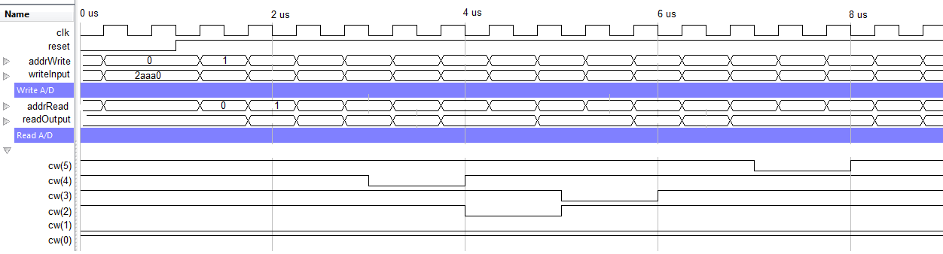

Addr | writeInput | WREN=cw(4) | WE=cw(3,2) | RDEN=cw(5) | readOutput
0x0 | 0x2AAA0
0x1 | 0x2AAA1
0x2
0x3
0x4
0x5
0x6
0x7
0x8 | 0x2AAA8
0x9
0xA
0xB
0xC
0xD
0xE | 0x2AAAE
0xF

-------------------------------------------------------------------------
-- Name: Prof Jeff Falkinburg
-- Date: Jan 29, 2017
-- File: lec13_dp.vhdl
-------------------------------------------------------------------------
library IEEE;
use IEEE.std_logic_1164.all;
use IEEE.NUMERIC_STD.ALL; -- contains the unsigned data type
library UNIMACRO; -- This contains links to the Xilinx block RAM
use UNIMACRO.vcomponents.all;

entity lec12Dual_dp is
Port( clk: in STD_LOGIC;
n_reset : in STD_LOGIC;
cw: std_logic_vector(5 downto 0));
end lec12Dual_dp;

architecture behavior of lec12Dual_dp is
signal writeInput, readOutput: std_logic_vector(17 downto 0);
signal addrWrite, addrRead: unsigned(9 downto 0);
signal vecAddrWrite, vecAddrRead : std_logic_vector(9 downto 0);
signal reset: std_logic;
begin
process(clk)
begin
if (rising_edge(clk)) then
if (n_reset = '0') then
addrWrite <= (others => '0');
elsif (cw(1 downto 0) = "01") then
addrWrite <= addrWrite + 1;
elsif (cw(1 downto 0) = "11") then
addrWrite <= (others => '0');
end if;
end if;
end process;

addrRead <= addrWrite - 1; -- Have the read follow the writes
writeInput <= "10101010101010" & vecAddrWrite(3 downto 0);
reset <= not n_reset; -- BRAM reset is active high
vecAddrWrite <= std_logic_vector(addrWrite); -- type conversion
vecAddrRead <= std_logic_vector(addrRead);

sampleMemory: BRAM_SDP_MACRO
generic map (
BRAM_SIZE => "18Kb", -- Target BRAM, "18Kb" or "36Kb"
DEVICE => "7SERIES", -- Target device: "VIRTEX5", "VIRTEX6", "SPARTAN6, 7SERIES"
DO_REG => 0, -- Optional output register disabled
INIT => X"000000000000000000", -- Initial values on output port
INIT_FILE => "NONE", -- Not sure how to initialize the RAM from a file
WRITE_WIDTH => 18, -- Valid values are 1-72 (37-72 valid when BRAM_SIZE="36Kb")
READ_WIDTH => 18, -- Valid values are 1-72 (37-72 valid when BRAM_SIZE="36Kb")
SIM_COLLISION_CHECK => "NONE", -- Simulation collision check
SRVAL => X"000000000000000000") -- Set/Reset value for port output
port map (
DO => readOutput, -- Output read data port width=READ_WIDTH
RDADDR => vecAddrRead, -- Read address, width=FNC(BRAM_SIZE)
RDCLK => clk, -- 1-bit input clock
RST => reset, -- active high reset
RDEN => cw(5), -- read enable
REGCE => '1', -- read output register enable - ignored
DI => writeInput, -- Input data port, width=WRITE_WIDTH
WE => cw(3 downto 2), -- RAM is byte read, high or low byte
WRADDR => vecAddrWrite, -- Write address, width=F(BRAM_SIZE)
WRCLK => clk, -- 1-bit input write clock
WREN => cw(4)); -- 1-bit master write enable
end behavior;

