Use the excel file accompanying Lesson 26 to generate the data in the table below – make sure to use the “second order” tab. When complete, plot the data in the empty graph at right to build the phase and magnitude plots.
Frequency  Cell B2 | Gain  Cell P10 | Phase  Cell P9
100
300
500
1,000
1,300
1,500
3,000
5,000
7,000
10,000
13,000
15,000
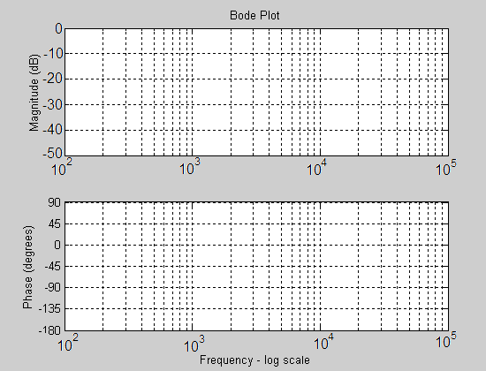

Calculate the slope of the Gain (to the right of the cut-off
frequency). Show your work here:

Use the equations presented in class to generate the coefficients
for a 2nd order low pass filter with a cut-off frequency of 300Hz.

Coefficient | Decimal | Fixed Point
X[n-2]
X[n-1]
X[n-0]
Y[n-1]
Y[n-2]

Build a project around the VHDL code for this lesson. Plug the coefficients for your filter above into the right channel filter. Synthesize your design, download and listen to the difference between the left and right audio channels.

-------------------------------------------------------------------------------------
Audio_Codec : Audio_Codec_Wrapper
Port map ( clk => clk,
reset_n => reset_n,
ac_mclk => ac_mclk,
ac_adc_sdata => ac_adc_sdata,
ac_dac_sdata => ac_dac_sdata,
ac_bclk => ac_bclk,
ac_lrclk => ac_lrclk,
ready => ready,
L_bus_in => LdacValue, -- left channel input to DAC
R_bus_in => RdacValue, -- right channel input to DAC
L_bus_out => LadcValue, -- left channel output from ADC
R_bus_out => RadcValue, -- right channel output from ADC
scl => scl,
sda => sda);
left_filter_lpf1000: entity work.IIR_Biquad(arch)
-- low pass 2nd order butterworth fl = 1000Hz, Fs = 48000Hz
-- http://www.earlevel.com/main/2013/10/13/biquad-calculator-v2/
generic map(Coef_b0 => B"00_00_0000_0100_0000_0010_1001_0110_1101", -- +0.003916127
Coef_b1 => B"00_00_0000_1000_0000_0101_0010_1101_1010", -- +0.007832253
Coef_b2 => B"00_00_0000_0100_0000_0010_1001_0110_1101", -- +0.003916127
Coef_a1 => B"10_00_1011_1101_0001_0111_0011_1010_0010", -- -1.815341083
Coef_a2 => B"00_11_0101_0010_1111_0011_0010_0001_0001") -- +0.831005589
port map ( clk => clk,
n_reset => reset,
sample_trig => ready,
X_in => LadcValue,
filter_done => OPEN,
Y_out => L_filter_lpf1000);
process (clk)
begin
if (rising_edge(clk)) then
if reset = '0' then
LdacValue <= (others => '0'); RdacValue <= (others => '0');
elsif(ready = '1') then
if (filter_switch = "00") then
LdacValue <= LadcValue; RdacValue <= RadcValue;
else
LdacValue <= L_filter_lpf1000; RdacValue <= R_filter_lpf1000;
end if;
end if;
end if;
end process;

