Direct Digital Synthesis (DDS) is a technique to create periodic waveforms with very precise frequency control using a system with a fixed clock frequency. The periodic function is stored in a look-up table, like the one below, which represents one cycle of a sine wave.
int8 sin[64] = {128,141,153,165,177,189,200,210,219,227,235,241,246,250,253,255,
255,254,252,248,244,238,231,223,214,205,194,183,171,159,147,134,
122,109, 97, 85, 73, 62, 51, 42, 33, 25, 18, 12, 8, 4, 2, 1,
1, 3, 6, 10, 15, 21, 29, 37, 46, 56, 67, 79, 91,103,115,128};
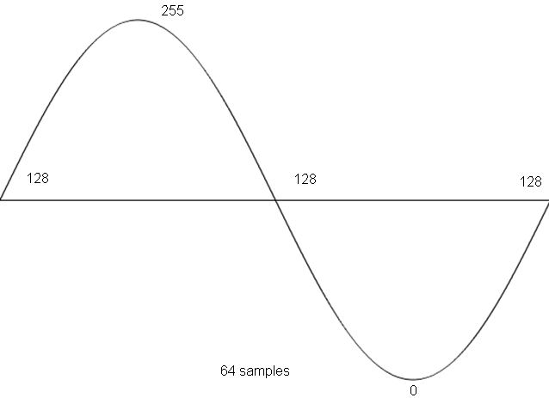

You are:
1) Given a lookup table with 2^N values corresponding to one wavelength of a function
2) Given a sampling rate or a play back rate of f updates/second
3) Given a phase increment x, which every 1/f is added to the index of the LUT

f updates x values 1 cycle f*x
--------- * --------- * --------- = --- hz
1 second update 2^N values 2^N

Questions:
Assuming an update rate of 48kHz, a LUT with 1024 entries, and a phase increment
of x, expressed as a 10.6 fixed point number. Answer the following questions.
- What is the maximum frequency we could generate?

- What is the minimum frequency we can generate?

- What is the smallest change in frequency we can make with the phase increment?

- What phase increment generates a frequency of 440hz?

- How did I arrive at the format of the phase increment?

