Mod-10 Counter state table
- Memory: The first line tells us that only a positive clock edge will result in an increment. Any other condition results in the next state of Q (denoted Q+) being unchanged (equal to Q).
- Reset: The second line defines the behavior when the reset is active low (to agree with the active-low reset on the Nexys Video board).
- Hold: The third row tells us that the counter will hold when the 2-bit control is equal to 00.
- Count Up: The fourth row tells us that the counter will count up when the 2-bit control is equal to 01. The "mod 10" means that the counter is supposed to count from 0 to 9 and then, on the next count, roll back to 0.
- Load D: The fifth row tells us that the counter will load in the value 'D' when the 2-bit control is equal to 10.
- Sync Reset: The sixth row tells us that the counter will synchronously reset when the 2-bit control is equal to 11.

clk | reset | ctrl | D | Q+
0,1,falling | x | xx | x | Q
rising | 0 | xx | x | 0
rising | 1 | 00 | x | Q
rising | 1 | 01 | x | Q+1 mod 10
rising | 1 | 10 | D | D
rising | 1 | 11 | x | 0

Complete the Q trace in the following timing diagram based on the state table for the mod-10 counter.

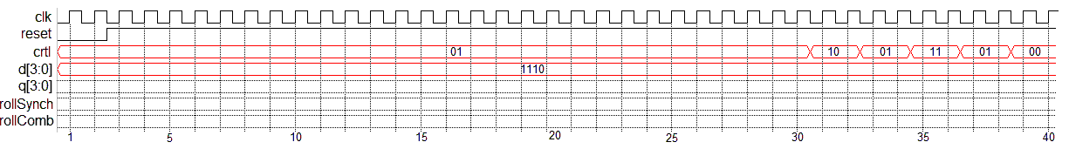
Using only comparators, a 4-bit register, and an adder construct the logic for the mod-10 counter.
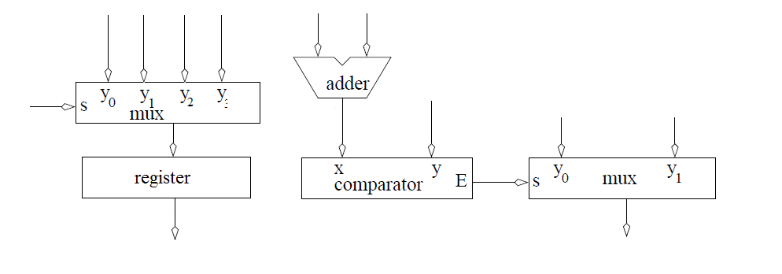
--------------------------------------------------------------------
-- Name: Chris Coulston
-- Date: Jan 13, 2015
-- File: lec04.vhdl
-- HW: Lecture 4
-- Crs: CSCE 436
-- Purp: Demo the use of processes for a mod 10 counter
-- Documentation: I pulled some information from chapter 8.
-- Academic Integrity Statement: I certify that, while others may have
-- assisted me in brain storming, debugging and validating this program,
-- the program itself is my own work. I understand that submitting code
-- which is the work of other individuals is a violation of the honor
-- code. I also understand that if I knowingly give my original work to
-- another individual is also a violation of the honor code.
-------------------------------------------------------------------------
library IEEE;
use IEEE.std_logic_1164.all;
use IEEE.NUMERIC_STD.ALL;

entity lec4 is
Port( clk: in STD_LOGIC;
reset : in STD_LOGIC;
ctrl: in std_logic_vector(1 downto 0);
D: in unsigned (3 downto 0);
Q: out unsigned (3 downto 0));
end lec4;

architecture behavior of lec4 is
signal rollSynch, rollCombo: STD_LOGIC;
signal processQ: unsigned (3 downto 0);
begin

-------------------------------------
-- ctrl behavior
-- 00 hold
-- 01 count up mod 10
-- 10 load D
-- 11 synch reset
-------------------------------------
process(clk)
begin
if (rising_edge(clk)) then
if (reset = '0') then
processQ <= (others => '0');
rollSynch <= '0';
elsif ((processQ < 9) and (ctrl = "01")) then
processQ <= processQ + 1;
rollSynch <= '0';
elsif ((processQ = 9) and (ctrl = "01")) then
processQ <= (others => '0');
rollSynch <= '1';
elsif (ctrl = "10") then
processQ <= unsigned(D);
elsif (ctrl = "11") then
processQ <= (others => '0');
end if;
end if;
end process;

rollCombo <= '1' when (processQ = 9) else '0';
Q <= processQ;

end behavior;

