Use the sinusoidal lookup table at left to generate a sine wave using a Q4.4 format phase increment of 0001.1011. Plot the “Base” and “Base + Offset*Delta” columns in the graph below.

0 | 127
1 | 175
2 | 216
3 | 244
4 | 253
5 | 244
6 | 216
7 | 175
8 | 127
9 | 78
10 | 37
11 | 9
12 | 0
13 | 9
14 | 36
15 | 78
Time | Index | Base | Delta | Offset*Delta | Base + Offset*Delta
0 | 0000.0000 | 127 | 175-127 = 48 = 110000 | 0.0000*110000 = 00000.0000 | 127+0 = 127
1 | 0001.1011 | 175 | 216-175 = 41 = 101001 | 0.1011*101001 = 11100.0011 | 175+28 = 203
2
3
4
5
6
7
8
9
10
11
12
13
14

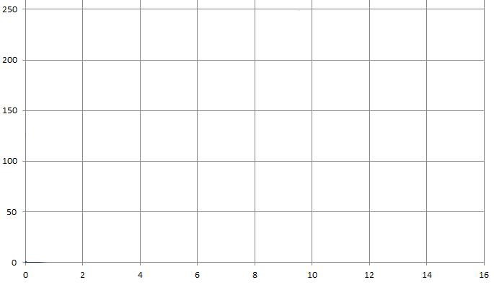

-------------------------------------------------------------------------------------
-- BRAM_SDP_MACRO: Simple Dual Port RAM 7 Series
-- Source: Xilinx HDL Libraries Guide, version 2012.4
-- Link: https://www.xilinx.com/support/documentation/sw_manuals/xilinx2012_2/ug953-vivado-7series-libraries.pdf
-- Page: 10
-------------------------------------------------------------------------------------

sampleMemory: BRAM_SDP_MACRO
generic map (
BRAM_SIZE => "18Kb", -- Target BRAM, "18Kb" or "36Kb"
DEVICE => "7SERIES", -- Target device: "VIRTEX5", "VIRTEX6", "SPARTAN6", "7SERIES"
DO_REG => 0, -- Optional output register disabled
INIT => X"000000000000000000", -- Initial values on output port
INIT_FILE => "NONE", --
WRITE_WIDTH => 16, -- Valid values are 1-72 (37-72 only valid when BRAM_SIZE="36Kb")
READ_WIDTH => 16, -- Valid values are 1-72 (37-72 only valid when BRAM_SIZE="36Kb")
SIM_COLLISION_CHECK => "NONE", -- Simulation collision check
SRVAL => X"000000000000000000", -- Set/Reset value for port output
INIT_00 => X"8BC28AF98A31896988A087D8870F8647857E84B583EC8323825A819180C88000",
INIT_01 => X"9830976A96A595DF95199452938C92C591FE913790708FA98EE18E198D528C8A",
INIT_02 => X"A462A3A2A2E0A21FA15DA09B9FD89F169E529D8F9CCB9C079B439A7F99BA98F5",
INIT_3E => X"7247717F70B76FF06F296E616D9A6CD46C0D6B476A8069BA68F5682F676A66A5",
INIT_3F => X"7ECF7E067D3D7C747BAC7AE37A1A7951788977C076F7762F7567749F73D6730E")
port map (
DO => DO, -- Output read data port, width defined by READ_WIDTH parameter
RDADDR => vecAddrRead, -- Input address, width defined by port depth
RDCLK => clk, -- 1-bit input clock
RST => reset, -- active high reset
RDEN => '1', -- read enable
REGCE => '1', -- 1-bit input read output register enable - ignored
DI => DI, -- Dummy write data - never used in this application
WE => "00", -- write to neither byte
WRADDR => "0000000000", -- Dummy place holder address
WRCLK => clk, -- 1-bit input write clock
WREN => '0'); -- we are not writing to this RAM

