-------------------------------------------------------------------------
-- File: lec18.vhdl
-- Ctrl: 00=Hold 01=Increment 10=Load 11=reset
-------------------------------------------------------------------------
entity lec10 is
generic( N : integer := 4);
port( clk : in STD_LOGIC;
reset_n : in STD_LOGIC;
ctrl : in std_logic_vector(1 downto 0);
D : in unsigned (N-1 downto 0);
Q : out unsigned (N-1 downto 0));
end lec10;
architecture behavior of lec10 is
signal processQ: __________________________________ ;
begin
process(clk)
begin
if (rising_edge(clk)) then
if (reset_n = '0') then
processQ <= ___________________ ;
elsif (ctrl = "01") then
processQ <= ___________________ ;
elsif (ctrl = "10") then
processQ <= ___________________ ;
elsif (crtl = "11") then
processQ <= ___________________ ;
end if;
end if;
end process;
Q <= processQ;
end behavior;
------------------------------------------------------------------------------
-- File: my_counter_ip_v1_0_S00_AXI.vhd
------------------------------------------------------------------------------
use ieee.numeric_std.all;

entity my_counter_ip_v1_0_S00_AXI is
generic (
-- Width of S_AXI data bus
C_S_AXI_DATA_WIDTH : integer := 32;
-- Width of S_AXI address bus
C_S_AXI_ADDR_WIDTH : integer := 7
);
port (
-- Users to add ports here
LED : out std_logic_vector(7 downto 0);
-- User ports ends
-- Do not modify the ports beyond this line
-- Global Clock Signal
S_AXI_ACLK : in std_logic;
-- Global Reset Signal. This Signal is Active LOW
S_AXI_ARESETN : in std_logic;
… lots of other stuff …);
architecture arch_imp of my_counter_ip_v1_0_S00_AXI is
------------------------------------------------
---- Signals for user logic register space example
--------------------------------------------------
component lec10 is
generic (N: integer := 4);
Port( clk: in STD_LOGIC;
reset_n : in STD_LOGIC;
ctrl: in std_logic_vector(1 downto 0);
D: in unsigned (N-1 downto 0);
Q: out unsigned (N-1 downto 0));
end component;

signal _________ : unsigned (7 downto 0);
begin
-- Address decoding for reading registers
loc_addr := axi_araddr(ADDR_LSB + OPT_MEM_ADDR_BITS downto ADDR_LSB);
case loc_addr is
when b"00000" =>
reg_data_out <= X"000000" & std_logic_vector(Q);
when b"00001" =>
reg_data_out <= slv_reg1;
when b"00010" =>
reg_data_out <= slv_reg2;
… lots more stuff here
end case;
-- Add user logic here
counter: ___________
generic map (____)
port map( clk => ___________________________,
reset_n => ___________________________,
ctrl => slv_reg1(1 downto 0),
D => unsigned(slv_reg0(7 downto 0)),
Q => ______________________________);
LED <= std_logic_vector(Q);
-- User logic ends
------------------------------------------------------------------------------
-- my_counter_ip_v1_0.vhd
------------------------------------------------------------------------------
use ieee.numeric_std.all;
entity my_counter_ip_v1_0 is
generic (
C_S00_AXI_DATA_WIDTH : integer := 32;
C_S00_AXI_ADDR_WIDTH : integer := 7
);
port (
-- Users to add ports here
LED : out std_logic_vector(7 downto 0);
-- User ports ends
-- Do not modify the ports beyond this line
-- Ports of Axi Slave Bus Interface S00_AXI
s00_axi_aclk : in std_logic;
s00_axi_aresetn : in std_logic;
… lots of other stuff …);

architecture arch_imp of my_counter_ip_v1_0 is
-- component declaration
component my_counter_ip_v1_0_S00_AXI is
generic (
C_S_AXI_DATA_WIDTH : integer := 32;
C_S_AXI_ADDR_WIDTH : integer := 7
);
port (
LED : out std_logic_vector(7 downto 0);
S_AXI_ACLK : in std_logic;-- Instantiation of Axi Bus Interface S00_AXI
… lots of other stuff …);

my_counter_ip_v1_0_S00_AXI_inst : my_counter_ip_v1_0_S00_AXI
port map( S_AXI_ACLK => S_AXI_ACLK,
S_AXI_ARESETN => S_AXI_ARESETN,
S_AXI_WDATA => S_AXI_WDATA,
… lots of other stuff …);my_counter_ip_v1_0_S00_AXI_inst : my_counter_ip_v1_0_S00_AXI
generic map (
C_S_AXI_DATA_WIDTH => C_S00_AXI_DATA_WIDTH,
C_S_AXI_ADDR_WIDTH => C_S00_AXI_ADDR_WIDTH )
port map (
LED => LED,
S_AXI_ACLK => s00_axi_aclk,
S_AXI_ARESETN => s00_axi_aresetn,
… lots of other stuff …);
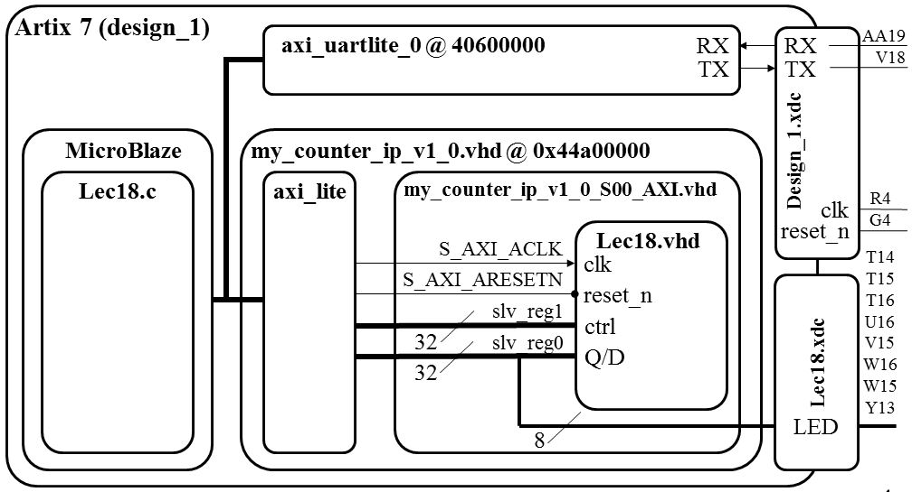

/*--------------------------------------------------------------------
-- Name: Maj Jeff Falkinburg
-- Date: Feb 16, 2017
-- File: lec18.c
-- Event: Lecture 18
-- Crs: ECE 383
--
-- Purp: MicroBlaze Tutorial that implements a custom IP to microBlaze.
--
-- Documentation: MicroBlaze Tutorial
--
-- Academic Integrity Statement: I certify that, while others may have
-- assisted me in brain storming, debugging and validating this program,
-- the program itself is my own work. I understand that submitting code
-- which is the work of other individuals is a violation of the honor
-- code. I also understand that if I knowingly give my original work to
-- another individual is also a violation of the honor code.
-------------------------------------------------------------------------*/

/***************************** Include Files ********************************/
#include "xparameters.h"
#include "stdio.h"
#include "xstatus.h"
#include "platform.h"
#include "xil_printf.h" // Contains xil_printf
#include <xuartlite_l.h> // Contains XUartLite_RecvByte
#include <xil_io.h> // Contains Xil_Out8 and its variations

/************************** Constant Definitions ****************************/

/*
* The following constants define the slave registers used for our Counter PCORE
*/
#define countQReg 0x44a00000 // 8 LSBs of slv_reg0 read=Q, write=D
#define countCtrlReg 0x44a00004 // 2 LSBs of slv_reg1 are control
#define countRollReg 0x44a00008 // 1 LSBs of slv_reg2 for roll

/*
* The following constants define the Counter commands
*/
#define count_HOLD 0x00 // The control bits are defined in the VHDL
#define count_COUNT 0x01 // code contained in lec18.vhdl. They are
#define count_LOAD 0x02 // added here to centralize the bit values in
#define count_RESET 0x03 // a single place.

#define printf xil_printf /* A smaller footprint printf */

#define uartRegAddr 0x40600000 // read <= RX, write => TX

/************************** Function Prototypes ****************************/

/************************** Variable Definitions **************************/

/*
* The following are declared globally so they are zeroed and so they are
* easily accessible from a debugger
*/

int main()
{
unsigned char c;

init_platform();

print("Welcome to Lecture 18\n\r");

while(1) {

c=XUartLite_RecvByte(uartRegAddr);

switch(c) {

/*-------------------------------------------------
* Reply with the help menu
*-------------------------------------------------
*/
case '?':
printf("--------------------------\r\n");
printf(" count Q = %x\r\n",Xil_In16(countQReg));
printf("--------------------------\r\n");
printf("?: help menu\r\n");
printf("o: k\r\n");
printf("c: COUNTER count up LEDs (by x26)\r\n");
printf("s: COUNTER start counter\r\n");
printf("l: COUNTER load counter\r\n");
printf("r: COUNTER reset counter\r\n");
printf("f: flush terminal\r\n");
break;

/*-------------------------------------------------
* Basic I/O loopback
*-------------------------------------------------
*/
case 'o':
printf("k \r\n");
break;

/*-------------------------------------------------
* Tell the counter to count up
*-------------------------------------------------
*/
case 'c':
Xil_Out8(countCtrlReg,count_COUNT);
Xil_Out8(countCtrlReg,count_HOLD);
break;

/*-------------------------------------------------
* Start the counter to count up
*-------------------------------------------------
*/
case 's':
Xil_Out8(countCtrlReg,count_COUNT);
break;

/*-------------------------------------------------
* Stop the counter from counting
*-------------------------------------------------
*/
case 'S':
Xil_Out8(countCtrlReg,count_HOLD);
break;
/*-------------------------------------------------
* Tell the counter to load a value
*-------------------------------------------------
*/
case 'l':
printf("Enter a 0-9 value to store in the counter: ");
c=XUartLite_RecvByte(uartRegAddr) - 0x30;
Xil_Out8(countQReg,c); // put value into slv_reg1
Xil_Out8(countCtrlReg,count_LOAD); // load command
printf("%c\r\n",c+0x30);
break;

/*-------------------------------------------------
* Reset the counter
*-------------------------------------------------
*/
case 'r':
Xil_Out8(countCtrlReg,count_RESET); // reset command
break;

/*-------------------------------------------------
* Clear the terminal window
*-------------------------------------------------
*/
case 'f':
for (c=0; c<40; c++) printf("\r\n");
break;

/*-------------------------------------------------
* Unknown character was
*-------------------------------------------------
*/
default:
printf("unrecognized character: %c\r\n",c);
break;
} // end case

}

cleanup_platform();

return 0;

} // end main

