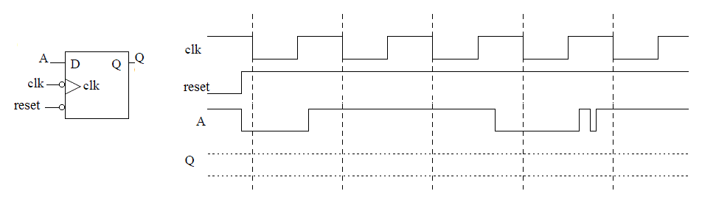

DAISY Inputs DAISY Outputs
RFID Scanner = r | Cow Present = c | Timer Status = t
1 - Cow checked in | 1 - cow present | 1 - timer up
0 - Cow not processed | 0 - no cow | 0 - timer running
Gate 1 | Gate 2 | Timer | Air Valve
0 – gate closed | 0 – gate closed | 00 Stop timer | 0 closed
1 - gate open | 1 – gate open | 01 Set to 30 sec | 1 open
 |  | 10 Set to 3 sec
 |  | 11 Run timer

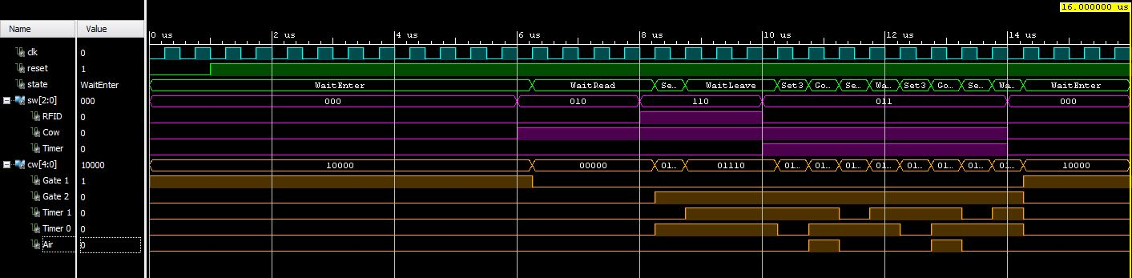

-------------------------------------------------------------------------
-- Name: Chris Coulston
-- Date: Jan 28, 2015
-- File: lec09.vhdl
-- Event: Lecture 9
-- Crs: ECE 383
-------------------------------------------------------------------------
library IEEE;
use IEEE.STD_LOGIC_1164.ALL;
use IEEE.NUMERIC_STD.ALL;

entity lec09 is
Port( clk: in STD_LOGIC;
reset : in STD_LOGIC;
sw: in STD_LOGIC_VECTOR(2 downto 0);
cw: out STD_LOGIC_VECTOR(4 downto 0));
end lec09;

architecture behavior of lec09 is

type state_type is (WaitEnter, WaitRead, Set30, WaitLeave, Set3, Goose);
signal state: state_type;

constant rfid: integer := 2; -- helps keep status bits straight
constant cow: integer := 1;
constant timer: integer := 0;

begin
state_process: process(clk,reset)
begin
if (rising_edge(clk)) then
if (reset = '0') then
state <= WaitEnter;
else
case state is
when WaitEnter =>
if (sw(cow) = '1') then state <= WaitRead; end if;
when WaitRead =>
if (sw(rfid) = '1') then state <= Set30; end if;
when Set30 =>
state <= WaitLeave;
when WaitLeave =>
if (sw(cow) = '0') then state <= WaitEnter;
elsif (sw(timer) = '1' and sw(cow) = '1') then state <= Set3; end if;
when Set3 =>
state <= Goose;
when Goose =>
if (sw(timer) = '1') then state <= Set30; end if;
end case;
end if;
end if;
end process;

cw <= "10000" when state = WaitEnter else
"00000" when state = WaitRead else
"01010" when state = Set30 else
"01110" when state = WaitLeave else
"01100" when state = Set3 else
"01111"; -- when state = Goose;

end behavior;

