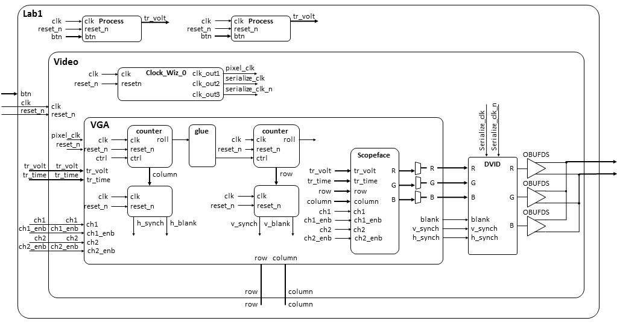
--------------------------------------------------------------------
-- Name: Maj Jeff Falkinburg
-- Date: Jan 12, 2017
-- File: lec5.vhdl
-- HW: Lecture 5
-- Crs: ECE 383
-- Purp: This demonstrates some basic I/O as well as gated and ungated
-- outputs.
-- Documentation: No help, I based this off the class notes and readings.
-------------------------------------------------------------------------
library IEEE;
use IEEE.STD_LOGIC_1164.ALL;
use IEEE.NUMERIC_STD.ALL;
entity Lec5 is
Port ( clk : in STD_LOGIC;
reset : in STD_LOGIC;
btn : in STD_LOGIC_VECTOR (4 downto 0);
JB : out STD_LOGIC_VECTOR (7 downto 0));
end Lec5;
architecture Behavioral of Lec5 is
signal processQ: unsigned (7 downto 0);
constant L0: unsigned(7 downto 0) := "00101111";
constant L1: unsigned(7 downto 0) := "01011111";
constant L2: unsigned(7 downto 0) := "10111111";
begin
------------------------------------------------------------------------------
-- The buttons are all nominally 0 and equal to 1 when pressed.
-- btn(3) = '1' Right
-- btn(1) = '1' Left
-- btn(2) = '1' Down
-- btn(0) = '1' Up
-- btn(4) = '1' Center
------------------------------------------------------------------------------
process(clk)
begin
if (rising_edge(clk)) then
if (reset = '0') then
processQ <= (others => '0');
elsif (btn(4) = '0') then
processQ <= processQ + 1;
end if;
end if;
end process;
------------------------------------------------------------------------------------
-- The upper nibble of JB will tell us about the range of processQ using combo logic
------------------------------------------------------------------------------------
process(clk)
begin
if (rising_edge(clk)) then
if (reset = '0') then
JB(6 downto 4) <= "000";
elsif ((processQ >= 0) and (processQ < L0)) then
JB(6 downto 4) <= "001";
elsif ((processQ >= L0) and (processQ < L1)) then
JB(6 downto 4) <= "010";
elsif ((processQ >= L1) and (processQ < L2)) then
JB(6 downto 4) <= "100";
elsif (processQ >= L2) then
JB(6 downto 4) <= "111";
end if;
end if;
end process;

JB(7) <= clk;

------------------------------------------------------------------------------------
-- The lower nibble of JB will tell us about the range of processQ using gated logic
------------------------------------------------------------------------------------
JB(3 downto 0) <= "0001" when ((processQ >= 0) and (processQ < L0)) else
"0010" when ((processQ >= L0) and (processQ < L1)) else
"0100" when ((processQ >= L1) and (processQ < L2)) else
"1000";

end Behavioral;

