--------------------------------------------------------------------
-- Name: Chris Coulston
-- Date: Jan 10, 2015
-- File: lec3.vhdl
-- HW: Lecture 3
-- Crs: ECE 383
-- Purp: Illustrate difference between unsigned and signed operations
-- Documentation: No help, I based this off the class notes and readings.
-- Academic Integrity Statement: I certify that, while others may have
-- assisted me in brain storming, debugging and validating this program,
-- the program itself is my own work. I understand that submitting code
-- which is the work of other individuals is a violation of the honor
-- code. I also understand that if I knowingly give my original work to
-- another individual is also a violation of the honor code.
-------------------------------------------------------------------------
library IEEE;
use IEEE.std_logic_1164.all;
use IEEE.NUMERIC_STD.ALL;

entity lec3 is
port( au, bu: in unsigned(3 downto 0);
cu,du,su: out unsigned(3 downto 0);
as, bs: in signed(3 downto 0);
cs,ds,ss: out signed(3 downto 0));
end lec3;

architecture structure of lec3 is
begin
cu <= "1000" when (au > bu) else
"0110" when (au = bu) else
"0001";
su <= au + bu;
du <= au - bu;

cs <= "1000" when (as > bs) else
"0110" when (as = bs) else
"0001";
ss <= as + bs;
ds <= as - bs;
end structure;

Unsigned
A | B | Value A | Value B | A >? B | A =? B | A <? B | A + B | A - B
0010 | 0100
1011 | 0001
0110 | 1010
0111 | 1000

Signed
A | B | Value A | Value B | A >? B | A =? B | A <? B | A + B | A - B
0010 | 0100
1011 | 0001
0110 | 1010
0111 | 1000

Page 18-19 from: Nexys Video™ Board Reference Manual
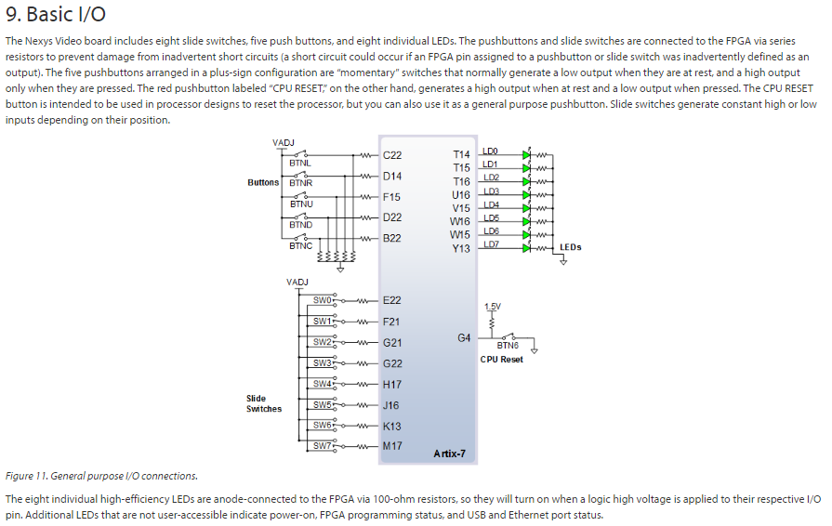
# This is slide switch SW0 #IO_L22P_T3_16 Sch=sw[0]
set_property -dict { PACKAGE_PIN E22 IOSTANDARD LVCMOS12 } [get_ports { a }];
# This is slide switch SW1 #IO_25_16 Sch=sw[1]
set_property -dict { PACKAGE_PIN F21 IOSTANDARD LVCMOS12 } [get_ports { b }];
# This is slide switch SW2 #IO_L24P_T3_16 Sch=sw[2]
set_property -dict { PACKAGE_PIN G21 IOSTANDARD LVCMOS12 } [get_ports { c }];
# This is LED Led(0) #IO_L15P_T2_DQS_13 Sch=led[0]
set_property -dict { PACKAGE_PIN T14 IOSTANDARD LVCMOS25 } [get_ports { f }];

