The Rotating Sky – Student Guide

I. Background Information
Work through the explanatory material on The Observer, Two Systems – Celestial, Horizon, the Paths of Stars, and Bands in the Sky. All of the concepts that are covered in these pages are used in the Rotating Sky Explorer and will be explored more fully there.

II. Introduction to the Rotating Sky Simulator
- Open the Rotating Sky Explorer
The Rotating Sky Explorer consists of a flat map of the Earth, Celestial Sphere, and a Horizon Diagram that are linked together. The explanations below will help you fully explore the capabilities of the simulator.
- You may click and drag either the celestial sphere or the horizon diagram to change your perspective.
- A flat map of the earth is found in the lower left which allows one to control the location of the observer on the Earth. You may either drag the map cursor to specify a location, type in values for the latitude and longitude directly, or use the arrow keys to make adjustments in 5° increments. You should practice dragging the observer to a few locations (North Pole, intersection of the Prime Meridian and the Tropic of Capricorn, etc.).
- Note how the Earth Map, Celestial Sphere, and Horizon Diagram are linked together. Grab the map cursor and slowly drag it back and forth vertically changing the observer’s latitude. Note how the observer’s location is reflected on the Earth at the center of the Celestial Sphere (this may occur on the back side of the earth out of view).
- Continue changing the observer’s latitude and note how this is reflected on the horizon diagram. When the observer is in the northern hemisphere the NCP is seen above the north point on the horizon at an altitude equal to the observer’s latitude. When the observer is in the southern hemisphere the SCP is seen above the south point at an altitude equal to the observer’s latitude.
- The Celestial Sphere and Horizon Diagram are also linked in that any stars are added to the simulation are shown on both. There are many features related to stars.
  - A star will be randomly created by clicking the add star randomly button.
  - A star may be created at a specific location on either sphere by shift-clicking at that location. (Hold down the shift key on the keyboard while clicking at that spot.)
  - You may move a star to any location by clicking on it and dragging it. Note that it moves on both spheres as you do this.
  - Note that the celestial equatorial and horizon coordinates are provided for the “active” star. Only one star (or none) may be active at a given time. Simply click on a star to make it the active star. Click on any other location to make no star active.
  - If you wish to delete a star, you should delete-click on it. (Hold down the delete key on the keyboard while clicking on the star.)
  - You may remove all stars by clicking the remove all stars button.
  - Note that stars are the vehicle by which you make coordinate measurements. If you want to make a measurement in either diagram – you place the active star at that location.
- There are several modes of animation as well as a slider to control speed.
  - You may turn on animate continuously or for preset time intervals: 1 hour, 3 hours, 6 hours, and 12 hours.
  - If you click-drag a sphere to change its perspective while the simulator is animating, the animation will cease. Once you release the mouse button the present animation mode will continue.
- This simulator has the power to create star trails on the horizon diagram.
  - A series of check boxes set the star trails option. No star trails is self-explanatory. Short star trails creates a trail behind a star illustrating its position for the past 3 hours. Long trails will trace out a parallel of declination in 1 sidereal day.
  - Stars are created without trails regardless of the trail option checked. If either short or long trails is checked, the trail will be drawn once the simulator is animated.
  - Existing star trails will be redrawn in response to changes – the star being dragged on either sphere or changing the observer’s location.
  - What’s not in this simulation? – the revolution of the Earth around the sun. This simulator animates in sidereal time. One sidereal day (one 360° rotation of the earth) is 23 hours and 56 minutes long. You should think of this simulator as showing the Earth isolated in space as opposed to revolving around the sun.

III. Horizon Coordinates
- Complete the following table involving the horizon coordinate system. You should predict the answers and then use the simulator to check them. Remember that you can measure coordinates by dragging the active star to that location.

Description | Latitude | Azimuth | Altitude
West point of the horizon | Any
Zenith | Any | Any
NCP | 30ºN
NCP | 71ºN
SCP | 52ºS
SCP | Tropic of Capricorn
Intersection of CE and Meridian | 40ºN
Intersection of CE and Meridian |  | 0º | 35º

- The next page contains a diagram known as a “fish-eye” view of the sky. Note that it is drawn like a sky-chart which is held up above your head and mimics the sky in that perspective. You should convince yourself that the east and west directions are shown correctly.
Star | Azimuth | Altitude
A | 0° | 20°
B | 90° | 0°
C | 180° | -5°
Assume that you are at a northern mid-latitude of 40° N. You will be asked to create stars at specified azimuths and altitudes. You will then be asked to make predictions about the locations and motions of the stars as time advances. After drawing in your predictions you should use the simulator to check your answer. If your original prediction was in error, redraw your star paths to reflect the correct motion.
  - Draw in the location of the North Celestial Pole. Note that since this location is directly above the Earth's North Pole it will not move in the sky as Earth rotates.
  - Draw in star A at the specified coordinates and assume that this is time t = 0 hrs. What will be the coordinates of star A at t = 6 hours? _______________________
At t = 12 hours? _____________________________________________________
At t = 24 hours? _____________________________________________________
Draw in each of these locations and connect the path between the stars. For what fraction of the day is star A visible? _____________________________
  - Draw in B at the specified coordinates and assume that this is time t = 0 hrs.
What will be the location of star B at t = 3 hours?
At t = 6 hours? _____________________________________________________
At t = 12 hours? _____________________________________________________
Draw in each of these locations and connect the path between the stars. For what fraction of the day is star B visible? _____________________________
  - Draw in C at the specified coordinates (as best you can) and assume that this is time t = 0 hrs. Estimate the coordinates of the star at t = 6 hours? _____________
At t = 12 hours? _____________________________________________________
At t = 24 hours? _____________________________________________________
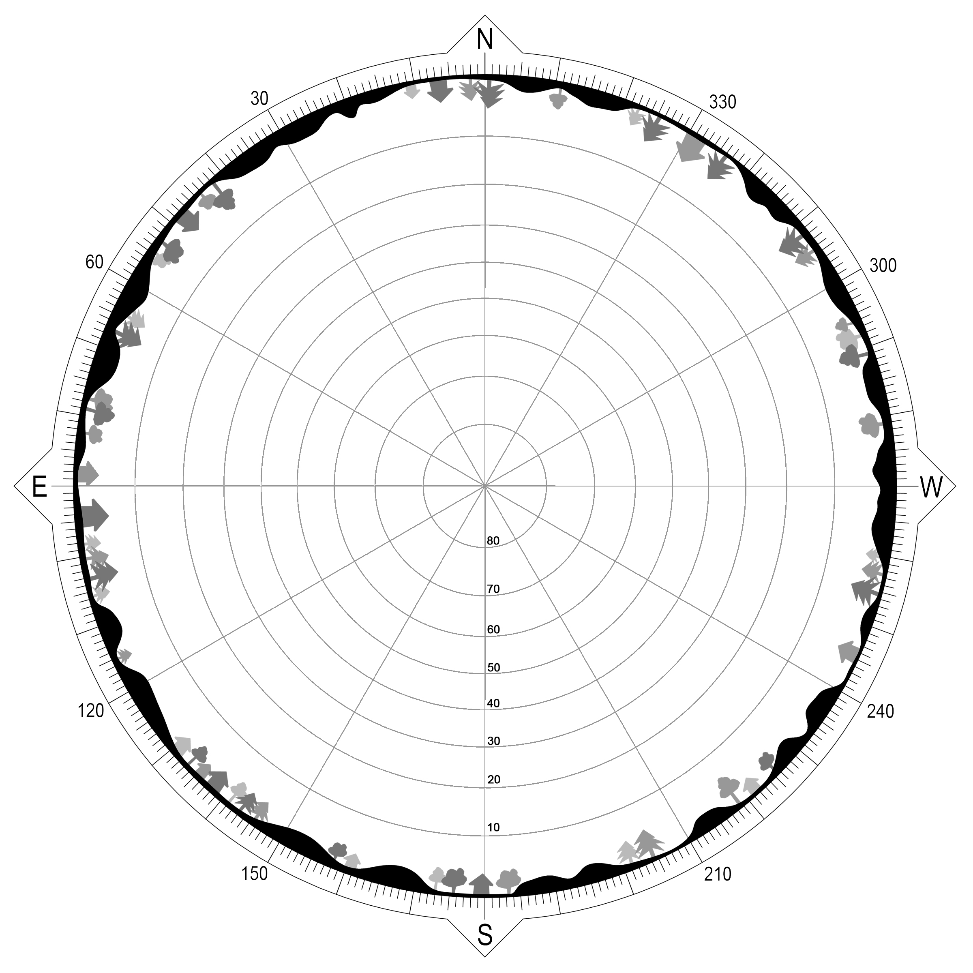
For what fraction of the day is star C visible? ______________________________

- Think about the characteristics of a star that passes through your zenith point (still at 40° N). Use the simulator to determine the following characteristics of this star.

Rising Azimuth = _____________________
Setting Azimuth = _____________________
Declination = ________________________

IV. Declination Ranges
- The two end stars of the Big Dipper are known as the “pointer stars” since a line drawn through them points toward Polaris (a very important marker in the sky since it is located very near the NCP). Use the constellations control to add the Big Dipper to the celestial sphere. Now manipulate the observer's location to estimate where on the Earth the Big Dipper can always be seen, where it sometimes can be seen, and where it never can be seen. (Hint: you will need to use the start animation control since the Big Dipper can be either above or below the NCP.) Repeat with Orion and the Southern Cross.
Star Pattern | Always Can  Be Seen | Sometimes Can  Be Seen | Never Can  Be Seen
Big Dipper
Orion
Southern Cross

- In which of the 3 declination ranges (circumpolar, rise and set, or never rise) are stars A, star B, and star C found?
Star A:
Star | Azimuth | Altitude
A | 0° | 20°
B | 90° | 0°
C | 180° | -5°
Star B:
Star C:
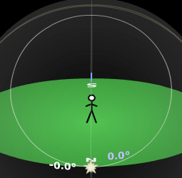
- Let’s explore the boundaries of these 3 regions. Make sure you are still at a latitude of 40º N, create a star, select the long trails option for star trails, and animate for 24 hours so that a complete parallel of declination is made for the star. Now drag this active star so that it is at the north point of the horizon. (Make sure the star is active so you can read off its coordinates.) Note that a star with a slightly smaller declination would dip below the north point while a star that is closer to the NCP would obviously be circumpolar. Thus, this star’s declination is a limiting value for the circumpolar declination range. Complete columns 2 and 3 for each of the given latitudes.
Latitude | North Point Declination | Circumpolar Range | South Point Declination | Rise & Set Range
10º N
25º N
40º N | +50º | +50º to +90º
55º N
70º N

Now drag the star to the south point on the horizon and read off the star’s declination. This is a limiting value for the never rise declination range. You should now be able to complete columns four and five in the table above.

- Set the simulator up for an observer on the equator. Create some stars (~20) in the simulator and click animate continuously. Describe the circumpolar stars seen from the equator.

- Set the simulator up for an observer at the south pole. Make sure that there are still stars (~20) in the simulator and click animate continuously. Describe the circumpolar stars seen from the south pole.

- Use your experiences from questions 6, 7, and 8 to help you state a general rule for identifying the three declination ranges given the observer’s latitude.

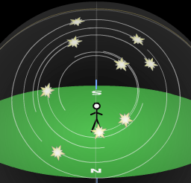
V. Star Trails
- Visualizing star trails is an important skill that is very closely related to declination ranges. Again set up the simulator for a latitude of 40º N, create about 20 stars randomly in the sky, turn on long star trails, and click animate continuously. The view to the right illustrates the region around the north celestial pole. Realize that we need to imagine what these trails would look like from the stick figure’s perspective.
Sketch the star trails from the observer’s perspective for each of the following latitudes and directions. You should indicate the position of a pole when looking N or S.
Latitude | Direction | Star Trail Description
40° N | N | 
40° N | S | 
40° N | E | 
40° N | W | 
90° N | ?? | Pole above horizon (at zenith)  
0° N | E | 
0° N | N (or S) | 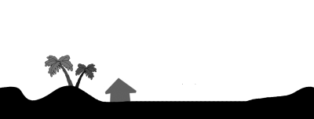

- Note that the simulator has a display option that illustrates the angle that the celestial equator makes with the horizon. The angle will be nearly the same for other parallels of declination (i.e. star trails) near the east or west point. Use the table below to record the star trail angle for rise and set stars at various latitudes.

Latitude | Direction | Star Trail Angle
10º N | E
25º N | E
40º N | E
55º N | E
70º N | E

- Describe a general rule for determining your latitude from looking at star trails.

VI. Sidereal Time & Hour Angle (optional)

Sidereal Time is used to describe the rotation of Earth and is needed to accurately point telescopes and keep track of the positions of objects in the sky. A sidereal day is the time needed for one complete rotation of Earth and is approximately 23 hours and 56 minutes long. If Earth were rotating isolated in space and a star were on the observer's meridian, it would take one sidereal day for it to return to the meridian again. The sidereal time is defined as the value of right ascension of an object on the observer's meridian.
Hour angle is defined as the angular distance measured westward along the celestial equator between the observer’s meridian and the meridian (RA value) passing through a celestial body. It is effectively how long until (or since) a body would (or did) travel through the observer’s meridian. If an object's hour angle is positive, then the object has already passed through the observer's meridian.
Hour angle is closely related to the sidereal time (also defined as the hour angle of the vernal equinox.) They are related through:
This simulator displays hour angle along the parallel of declination containing the object of interest. This is consistent with the idea of HA being the time before/after transiting the observer's meridian. Technically it should be shown on the celestial equator.

Hour Angle = Local Sidereal Time – Right Ascension HA = LST - RA

This equation effectively says: "If the right ascension of the object of interest (RA) is greater than the right ascension of a point on the observer's meridian (LST) --- then the hour angle (HA) is negative and the object has not yet reached the meridian."

- Use the SiderealTimeandHourAngle demonstrator to answer the following questions. Assume the observer is at a mid northern latitude of 40º N.
  - A star is on the observer’s meridian. What is its hour angle?

  - A star is on the celestial equator and the eastern horizon. What is its hour angle?

  - On the Vernal Equinox at noon, what is the hour angle of a star with a right ascension of 2 hours?

  - On the summer solstice at midnight, what is the hour angle of a star with a right ascension of 22 hours?

