Basic Coordinates & Seasons – Student Guide

There are three main sections to this module: terrestrial coordinates, celestial equatorial coordinates, and understanding how the ecliptic is related to seasons on the Earth. Each of these sections has its own simulator(s). The background material necessary to utilize these tools is contained in each section.

Terrestrial Coordinates
Work through the explanatory material on units of longitude and latitude, finding longitude and latitude, and a bit of history (optional).
- Open the flat map explorer.
- Familiarize yourself with the cursor and how it prints out the longitude and latitude of the active map location.
- Note that you can vary the central meridian of the map (i.e. change its longitude). Use the “shift map” arrows at the top of the simulator to affect large rapid changes. Use the shift-click feature of the cursor for finer control.
- Note what information is accessible through the show cities and show map features check boxes.
- Center the cursor on your present location. Click the open Google Maps button to launch the Google Map tool focused on this location. Experiment until you get a good feeling for the Google Map’s capabilities and then close this window. (Note that you must be connected to the Internet to make use of this feature.)

- Use the flat map explorer to complete the following table. You are encouraged to try and predict the answers and then use the map’s cursor and other features to check the accuracy of your estimates.
Location | Longitude | Latitude
The center of the island of Madagascar.
 | 157.5º W | 21.2º N
 | Prime Meridian | 51.8º N
 | 82.1º W | Tropic of Cancer
Sao Paulo, Brazil
 | International Date Line | Arctic Circle
 | 90º W Meridian | 30º N Parallel
- Determine which of the 50 states defines the farthest extent of the United States in each of the 4 map directions.
Direction | State
North
South
East (there are two ways of thinking about this)
West

- The exact coordinates of the white house in Washington D.C., are 77.0365º W and 38.897º N. What are these exact coordinates in sexagesimal notation? Show your calculation in the box below. (You can use the Google Map tool to check your answer.)

- Open the globe explorer. You are encouraged to use the Terrestrial Coordinate Explorers link which opens both simulators at the same time for the following two questions. Familiarize yourself with the features noting that they are very similar to those in the flat map explorer.

- A) Where is the north pole on the flat map explorer? What is its shape?

B) Where is the north pole on the globe explorer? What is its shape?
C) Your answers to parts A and B should be different. Explain why.
- Compare the relative sizes of Greenland and Australia in the two maps? The true values of the surface areas for these countries are Greenland (2.2 million km²) and Australia (7.7 million km²). Does each map demonstrate these true values?

Celestial Equatorial Coordinates
Work through the introductory material on the page entitled Celestial Equator, Declination, Right Ascension.
- Open either the Flat Sky Map Explorer or the Sky Map Explorer.
- Familiarize yourself with the same set of features (cursor movement, shifting the map, decimal/sexagesimal) that were available on the previous maps.
- Make sure that you understand what each check box does.
- Where is the star Polaris located on this map? What are its coordinates?
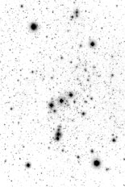
- Find the constellation of Orion shown in the box below and measure the right ascension and declination of its brightest stars Betelgeuse and Rigel. Note that Orion is located on the celestial equator.

RA
DEC
RA
DEC

- Which direction is east on the flat sky map? Relate this to a coordinate of the celestial equatorial system.
- Complete the following table of positions on the ecliptic.
Ecliptic Location | Approximate Date | Right Ascension | Declination
Vernal Equinox | March 21
Summer Solstice | June 21
Autumnal Equinox
 | December 21

- Write out a description of the ecliptic on the flat sky map. What does the shape look like? Describe the ecliptic in terms of its average and range of declination values.

Seasons and the Ecliptic
Work through the introductory material on the page entitled Orbits and Light.
- Open the Seasons and Ecliptic Simulator.
- Note that there are three main panels (left, upper right, and lower right) each of which have two different views. Controls run along the bottom of the simulation that affect more than one panel. Click animate and then move through the six views to get an overview this simulator’s capabilities. We will address each of these six views separately.
- Experiment with the various methods to advance time in the simulator. You may click the start animate/stop animation button, drag the yearly time slider, or drag either the sun or the earth in the left panel to advance time.
- Note that this animation does not illustrate the rotation of the earth. Because the timescales of rotation and revolution are so different, it isn’t possible to effectively show both simultaneously.

Left Panel – Orbit View
Tip: Note that if you click and drag the Earth, you will change the date and location rather than the perspective.
- Practice clicking and dragging in this panel to change the perspective. Change the perspective so that you are looking directly down onto the plane of the Earth’s orbit
- Click labels. Note that you can see how the direct rays of the sun hit at different latitudes throughout the year.
- Experiment with this view until you can quickly create the two views shown below. Note that these images explain the shape of the elliptic on the celestial sphere. In the image on the left (summer solstice) an observer on the Earth sees the sun above the celestial equator. In the image on the right (winter solstice) an observer on the Earth sees the sun below the celestial equator.
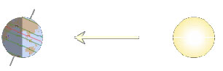
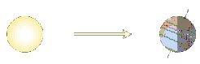

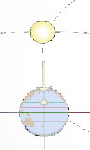
Left Panel – Celestial Sphere

- This view shows the earth at the center of the celestial sphere. The celestial equator and the ecliptic with the sun’s location are shown. Note that you may click on the sun and drag it and read out its coordinates.
- Experiment with this view until you can quickly create the image to the right – the direct rays of the sun hitting the earth on the summer solstice.

Upper Right Panel – View from Sun

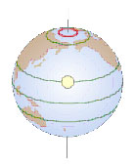
- This view shows the earth as seen from the sun. It gives the best view of the subsolar point – the location on the earth where the direct rays of the sun are hitting. The noon observer’s location on the Earth is indicated by a red parallel of latitude which can be dragged to new latitudes (this affects the appearance of the lower right panel). It is possible for the red parallel to be at an inaccessible location in this view.
- Create the image shown to the right – an observer at latitude 80°N on the summer solstice.

Upper Right Panel – View from Side
Tip: Once the stick figure is selected you can gain greater precision over its motion by moving the mouse a distance away from the figure.
- This view shows the earth as seen from a location in the plane of the ecliptic along a line tangent to the Earth’s orbit. It allows one to easily see the regions of the Earth that are in daylight and those that are in shadow.
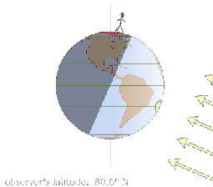
- Dragging the stick figure allows one to very conveniently change latitude. Dragging the stick figure on top of the subsolar point effectively puts the observer at the latitude where the direct rays of the sun are hitting.
- Although rotation is suppressed in this simulation, keep in mind that the stick figure is on a planet that is rotating with a period of 24 hours about an axis connecting the north and south poles. Thus, 12 hours later it will be on the other side of the earth.
- Set up the simulator for the image at right – the winter solstice for an observer at 80° N. Since this observer’s parallel of latitude is located entirely in the shaded region, this observer will not see the sun on this day.

Lower Right Panel – Sunbeam Spread

- This view shows a “cylinder” of light coming from the sun. It is projected on a grid to convey the area over which the light is spread. As this light is spread over a larger area, its intensity decreases.

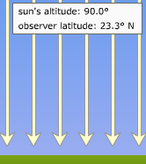
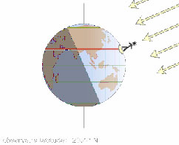
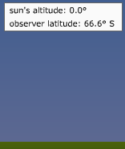
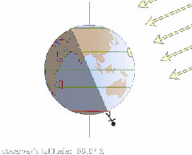
Lower Right Panel – Sunlight Angle

- This view shows the angle with which rays of sunlight are striking the Earth. It lists the noon sun’s angle with respect to the horizon (its altitude).
- Verify that when the noon observer is at the latitude where the most direct rays of the sun are hitting, the sun is directly overhead making an angle of 90° with the ground.
- Verify that when the noon observer is at the latitude where the least direct rays of the sun are hitting, the sun is on the horizon.

- The table below contains entries for the coordinates for the sun on the ecliptic as well as the latitude at which the most direct and least direct rays of the sun are hitting. Use the simulation to complete the table.

Date | RA | DEC | Latitude of Most Direct | Latitude of Least Direct Ray
February 5
March 21
May 5 | 2.9 h | +16.5° | 16.5° N | 73.5° S
June 21
August 5
September 21
November 5
December 21

- Using the data in the table above, formulate general rules relating the declination of the sun to the latitude where the most direct and least direct rays of the sun are hitting.
- The region between the Tropic of Cancer and the Tropic of Capricorn is commonly known as the tropics. Using the sunlight data table from question 11, define the significance of this region.
- Using the sunlight data table from question 11, define the significance of the region north of the Arctic Circle commonly referred to simply as the Arctic.
- Use the simulator to complete the table below. For each latitude write a short paragraph which describes the variations in sunlight (seasons) that are experienced at this latitude throughout the year.
Latitude | Description of Yearly Pattern of Sunlight
0° | The noon sun’s angular height above the horizon ranges from 90° on the vernal equinox, to 66.5° on the summer solstice, to 90° on the autumnal equinox, and back to 66.5° on the winter solstice. Thus, the equator always receives very direct intense sunlight throughout the year which accounts for the very high temperatures.
23.5° N
41° N
66.5° N
90° N

