NAAP InClass Worksheet: Basic Coordinates and Seasons Module (Instructor Version)
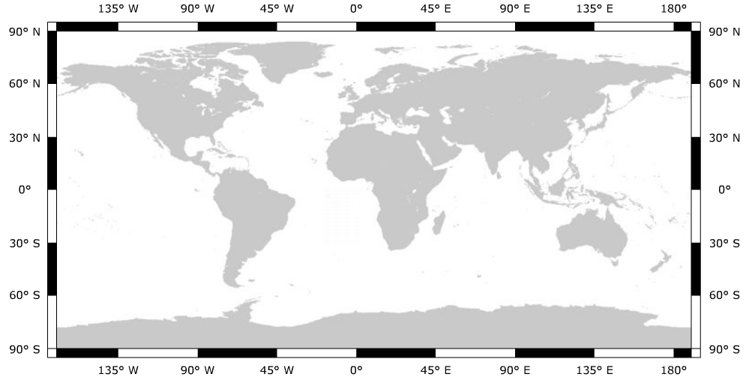
Start the flat map explorer. Drag the “hot point” to an inconspicuous location.

Terrestrial
Coordinates

- Add the following Map features to your terrestrial flat map.
  - the Prime Meridian
  - the Equator
  - the Tropics of Cancer and Capricorn
You should now check show map features so students can verify their answers.
  - the Arctic and Antarctic Circle
- Add the following cities to your terrestrial flat map
  - Greenwich, England – latitude: 51.3ºN, longitude: 0.0ºW
You should now check show cities so students can verify their answers. You may wish to drag the “hot point” to these locations.
  - Lima, Peru – latitude: 12.3ºS, longitude: 76.9ºW
  - Beijing, China – latitude: 39.5ºN, longitude: 116.6ºE
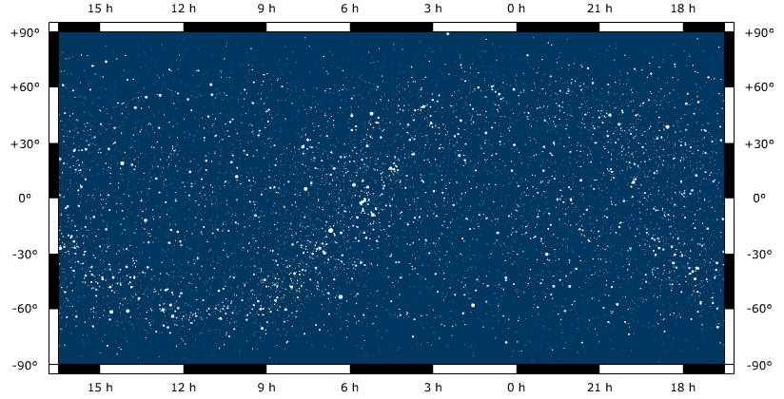

Celestial
Equatorial
Coordinates

- Add the following to your celestial sphere flat map
  - Place a small circle around Polaris (the north star)
  - Draw in the celestial equator
  - Draw in the ecliptic
You should now check show celestial equator, show ecliptic, and show equinoxes and solstices and you can check your answers.
  - Label the locations: vernal equinox, summer solstice, autumnal
equinox, winter solstice
- Notate the following positions on your graph
  - α = 12^{h} 45’ δ = -35º
  - α = 19^{h} 15’ δ = +65º
Move the “hot point” to these locations.
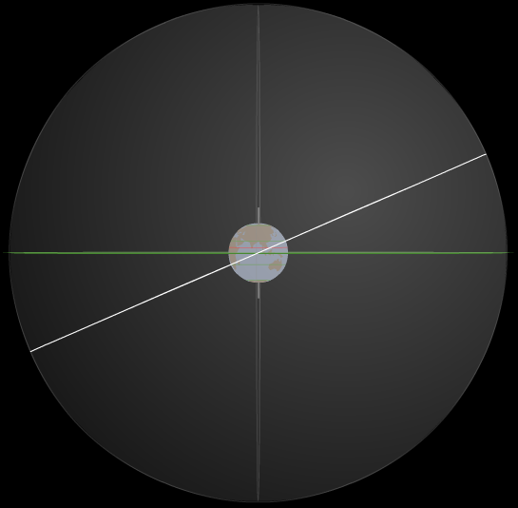
The diagram to the right illustrates the celestial sphere with the celestial equator (horizontal, dark) and ecliptic (white).
Open the Seasons and Ecliptic Simulator and select Celestial Sphere view. Change the date to June 21 and manipulate the sphere until you obtain the perspective shown here.

5. Note the following locations on the diagram.
a. north pole
b. south celestial pole
c. summer solstice
d. winter solstice
e. vernal equinox
Check labels so students can check their answers. You will need to tilt the sphere downward quite a bit for them to see the arrows pointing to the equinox positions.

The diagram to the right show the rays of the sun hitting the Earth on the summer solstice. Note that the direct rays of the sun are hitting at a latitude of 23.5ºN on the Tropic of Cancer.
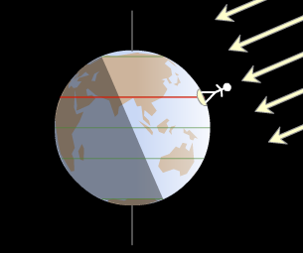
6. Annotate the following on the diagram.
Drag the observer in the upper right panel to the Tropic of Cancer as shown. The day should still be the Summer Solstice.

- shade any areas on the earth where the sun doesn’t rise on this day.
- Use cross-hatching to mark any areas on the Earth where the sun doesn’t set on this day.
There is no direct method in the simulator to display this. You will need to point out the region south of the Antarctic Circle for (a) and the region north of the Arctic Circle for (b). You can drag the observer up above the Arctic Circle (and below the Antarctic) and ask student to think about whether the observer crosses from the lighted area into the shade (or vice versa) during a day (one rotation around the pole)

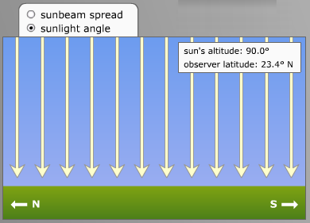
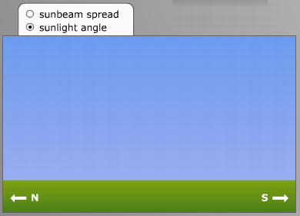
The diagram below shows what the rays of the sun look like striking the earth on the Tropic of Cancer on the Summer Solstice. In the box to the right draw these rays as seen by an observer on the Tropic of Capricorn.
Drag the observer to the Tropic of Capricorn so students can check their answer. Students should be able to reason that the observer is about halfway between where the sun is at the zenith and where it is at the horizon and get an answer of 45º.

An exact answer can be obtained by reasoning that the sun moved 23.5º degrees from the zenith to get to the Equator and another 23.5º to get to the Tropic of Capricorn. Thus, at its highest point the sun is 47º away from the zenith at an altitude of 43º. Better tools for thinking about this are covered in the Motions of the Sun Module.

