Lunar Phase Simulator – Student Guide

Part I: Background Material
Answer the following questions after reviewing the background pages for the simulator.

Page 1 – Introduction to Moon Phases

Is there a dark side of the moon? (Note: this question can be effectively answered either yes or no, so it is important to explain your reasoning.) ________________________________________________________________________________________________________________________________________________________________________________________________________________________________________________________________________________________________________________________________________________________________________

How long does it take the moon to complete one cycle of phases, in days? ____________

If the moon is full today, what phase do you expect it to be at in a week? _____________

How about one month later? _____________

Many words in astronomy also non-astronomical uses as well. Using your knowledge of how the terms on the left are used in astronomy match them with the non-astronomical uses on the right.
waning | convex, rounded -- also hunch-backed, having a hump
gibbous | to increase in size, quantity, volume, intensity, etc.
waxing | decrease in magnitude, importance, brilliancy, intensity, etc.

The following sketches of the moon's appearance were made over about four weeks. Identify the phases and put them in the correct numerical order. One is labeled for you.

Picture |  | Order | Phase |  | Picture |  | Order | Phase
A | 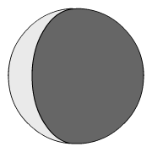 |  |  |  | D | 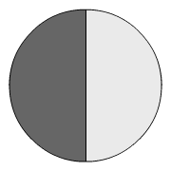
B | 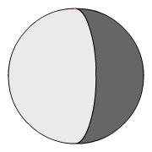 | 1 | waning gibbous |  | E | 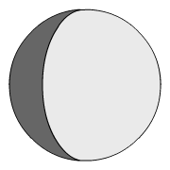
C | 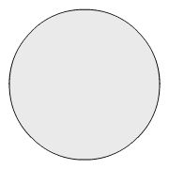 |  |  |  | F | 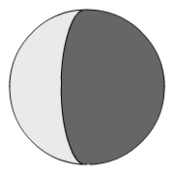

Page 2 – Introduction to Moon Phases

From the perspective of an observer above the North Pole, the moon moves clockwise / counter-clockwise (circle) in its orbit around the earth.
In the diagram below the sun's light is coming in from the right. The moon's location is marked at several points on its orbit. These are the points the moon was at when the sketches above were drawn. Identify each position with the letter of the corresponding sketch.
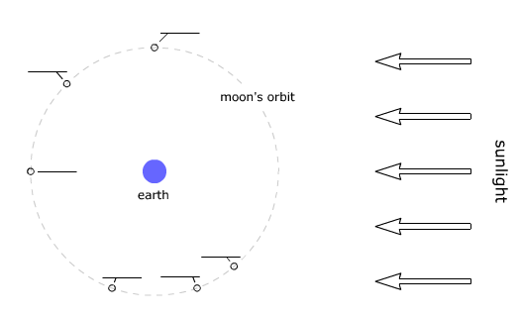

Page 3 – The Time of Day

Use the interactive diagram at the bottom of the page to determine the direction of the earth’s rotation when viewed from above the North Pole. (Hint: rotate the observer – the stickfigure – to the noontime position, then sunset position, then midnight position, and finally back to sunrise position. The earth has made one complete rotation and the observer has experience one daily (diurnal) cycle of day and night.)
When viewed from above the North Pole, does the earth rotate clockwise or counter-clockwise? __________________

Page 4 – Rising and Setting

When the moon crosses the western side of the horizon plane it is rising / setting (circle). When it crosses the eastern side of the horizon plane it is rising / setting (circle).

Page 5 – The Horizon Diagram

Describe the location of the moon in the sky of the horizon diagram at bottom. Use direction words (like north, west, etc.) and estimate its altitude in degrees.

________________________________________________________________________________________________________________________________________________

Page 6 – The Witness and the Detective

If we know the moon's position in the sky and its phase, we can estimate the ____________. In general, knowing any two of the following three things allows us to estimate the third:
1. moon's position in the sky
2. __________________________________
3. __________________________________

Part II: Visualizing Phases

- We can determine the appearance of the moon based on the orientation of the moon and sun with a simple heuristic. In the figure below, bisect the moon twice.
  - Draw a line (perpendicular to the direction of sunlight) that shows the half of the entire moon that is illuminated and shade the shadowed region.
  - Draw a line (perpendicular to the Earth-moon line) that shows the half of the moon visible for an observer on earth.
  - Mark the region that is both visible from earth and illuminated by the sun. That region will be the phase of the moon we on earth see.
Moon

Earth

sunlight

We normally draw the phases of the moon with the terminator (the dividing line between light and shadow) from the north pole to the south pole of the moon. This is how the moon would be seen if it were on the observer’s meridian. We can use the drawing above to determine the amount of illumination and whether it is on the left or right hand side of the moon. Use the drawing above to draw the appearance of the moon in the box below.

Open the Moon Bisector Demo and use the simulator to check your answer to the above problem.

Part III: Working with the Lunar Phase Simulator
The items below will help familiarize yourself with the controls and usability features of the simulator.
- If you have not already done so, launch the NAAP Lunar Phase Simulator
- The main panel has sunlight, the earth, and moon. The earth and moon can be dragged with the mouse.
- Below the main panel, there are animation controls. The moon and earth can be dragged.
- The increment buttons move both the moon and earth by the specified time.
- The Moon Phase panel shows the current moon phase. Drop down menus will jump to a predefined position. Note that the phases, such as crescent and gibbous, are more broad than the particular point chosen by the presets.
- The Horizon Diagram panel displays the point of view of the observer (and you are a second observer looking down on that observer).
- The observer’s horizon diagram can be dragged to allow for the most convenient viewing orientation.
- The sun and moon on the globe can be dragged around.
- In the Diagram Options panel, the show angle option shows the earth-moon-sun angle. The phases are technically defined in terms of this angle.
- In the Diagram Options panel, the show lunar landmark option draws a point of reference to more easily observer lunar rotation and revolution.
- In the Diagram Options panel, the show time tickmarks option displays the time of day of the observer.

Earth – Moon – Sun Geometry
- Click on the option labeled show angle – which graphically displays the angle between the direction of the sun and moon. Now drag the moon around the sun to a variety of different locations and note the appearance of the Moon Phase. Describe how the value of the angle correlates with the appearance of the moon.
________________________________________________________________________
________________________________________________________________________
________________________________________________________________________
________________________________________________________________________
________________________________________________________________________
- Each row on the following table shows diagram of the earth-moon system. For each diagram, find the age of the moon at that position (that is, the time passed since new moon), its phase, and its percent illumination. Finally, make a sketch of its general appearance. You will need to take into account the orientation of the sunlight – it is different in each diagram from the orientation in the applet. The first row is completed for you. You may need to rotate your paper and hold it up to the screen to check your answers.

Moon Geometry | Age | Phase | Percent Illumination | Sketch
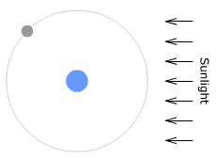 | 11 days,  9 hours | Waxing Gibbous | 88%
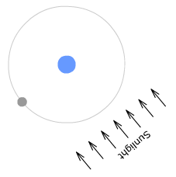 |  |  |  | 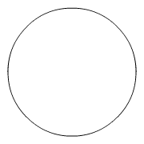
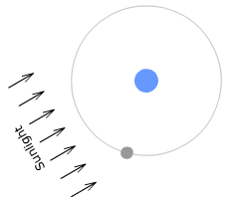
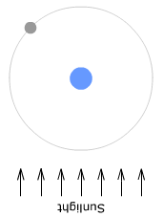
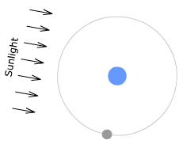
Rising, Setting, and Meridian Times

When observing the moon one thing we might like to know in advance is when it is visible – what time it sets, rises, and crosses the meridian (or transits). The applet can help find these times.

Example 1: What is the meridian crossing (transit) time for a new moon?

Move the moon to its new position. Rotate the earth until the moon is centered on the meridian (the observer should be located on the earth directly opposite the moon) . For finding transit times it helps to change the perspective of the horizon diagram (by clicking and dragging on it) so that we are looking straight down on the diagram. Note that the transit time of the new moon is 12:00 PM (noon). Complete the rest of the meridian times in the table below.

 | Rising | Meridian Crossing | Setting
New |  | 12:00 PM
Waxing Crescent
First Quarter
Waxing Gibbous
Full |  |  | 6:00 AM
Waning Gibbous
Last Quarter
Waning Crescent
Example 2: What is the setting time for a full moon?

First we move the moon to the full position by dragging it, or selecting ‘Full Moon’ in the phase name drop down list. Next, click on and rotate the earth while keeping an eye on the horizon diagram in the lower right corner. Rotate the earth until the moon just disappears below the western horizon. You should verify that this occurs at 6:00 AM. Complete the rest of the rising and setting times in the table above.
- Describe the relationship between the values of the meridian times and the rising and setting times in your table.
________________________________________________________________________
________________________________________________________________________
________________________________________________________________________
________________________________________________________________________
________________________________________________________________________
Part IV: Lunar Phases in the Horizon Diagram

This module also contains another simulator especially for gaining insight into the lunar phases in the horizon system. Please load the Moon Phases and the Horizon Diagram Simulator. Follow the guidelines below to gain familiarity with the simulator. Please begin by unchecking all options.

Click the option entitled show ecliptic band. Since the ecliptic can be as much as 23.5º away from the celestial equator and the plane of the moon’s orbit is inclined almost 6 degrees to the plane of the ecliptic – the moon can be located in a band almost 60º wide in the sky. We assume for this lab that the moon is always located on the celestial equator. Unclick show ecliptic band.

For simplicity’s sake we identify 8 distinct locations for the sun corresponding to 8 distinct times. Click show sun and use the slider to manipulate the sun’s position. Place the sun at the appropriate location for each of the following times: 6 am, 9 am, noon, 3 pm, 6 pm, 9 pm, midnight, and 3 am.

Place the sun at the noon position (position 3). Note that that the phase of the moon is new in this orientation.Click show moon and place the moon at position 3 as well. Click show phase and show phase on moon disc. Now step through the 8 possible positions by moving the moon eastward. Note that when the moon is one position east of the sun, its phase is waxing crescent. When the moon is two positions east of the sun its phase is first quarter. Move the moon through the remaining phases of the cycle.

Thus, there are two general rules for solving problems in the horizon system.

The time is denoted by the position of the sun.

The phase of the moon is denoted by how many (out of the 8 steps) the moon is east of the sun.

- Complete the following table. You are encouraged to visualize the solutions in horizon diagrams drawn on scratch paper or in your head and then use the simulation to check your answer.

 | Time | Location | Phase
A | Noon | First Quarter
B | 3 pm | First Quarter
C |  | First Quarter | Western horizon
D | 9 pm | Waning Gibbous
E | 3 am |  | Southwest
F | Midnight | Waxing Gibbous
G |  | Waxing Crescent | Southeast

Close the Moon Phases and the Horizon Diagram Simulator and return to the Lunar Phase Simulator and answer each of the following questions.

- The figure below shows the moon and sun on a horizon diagram. What is the phase and what is the time of day depicted? What time did the moon reach its highest point in the sky?
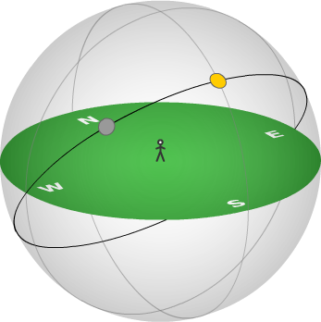
sun
moon

- In the figure above, draw and label the moon’s location 48 hours later. Will the moon be visible at noon 14 days later?
Explain your answer:

- Draw and label the full moon and sun at 6:00 A.M. on the figure below. (If necessary or useful, draw an arrow to one or both spots.)
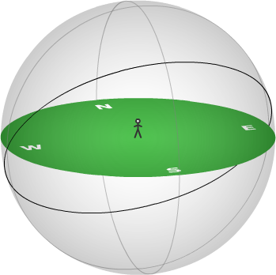

Part V: Advanced Application
An article entitled Muslim Moon Sightings is attached. Write a short essay complete with diagrams describing how you were able to simulate the observations described in the article in the Lunar Phase Simulator.

