In Class Worksheet (Lunar Phase Simulator)

- Sketch the shadows for Sun-Earth-Moon Geometry shown below. Then sketch the appearance of the moon as seen from the earth and notate the name of the phase.
Moon’s Appearance
Name of Phase: ________________
Sun-Earth-Moon Geometry
Earth
moon
Sunlight

- Sketch the appearance of the moon and notate the name of the phase for the new geometry below.
Name of Phase: ________________
Earth
moon
Sunlight

- Complete both drawings for the position and appearance of the moon 3 days later than part #2.
Earth
Name of Phase: ________________
Sunlight

- Draw in the location of the sun and moon in the horizon diagram for the earth-moon geometry shown.
Earth
moon
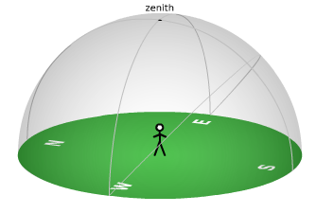
Sunlight

5. Draw locations of the moon and observer in the Earth-Moon Geometry diagram and the locations of the sun and moon in the horizon diagram 6 hours later than part #4.
Sunlight

Earth

6. Estimate the angle between the sun and moon in part #5.

Angle = _________________________

