NAAP InClass Worksheet: Lunar Phases Module (Instructor Version)

- Sketch the shadows for Sun-Earth-Moon Geometry shown below. Then sketch the appearance of the moon as seen from the earth and notate the name of the phase.
You should start the simulator and drag the moon to the position shown. Hide the Moon Phase panel. You may need to remind students that the perspective shown is from above the North Pole.
Moon’s Appearance
Name of Phase: ________________
Earth
moon
Sun-Earth-Moon Geometry
Sunlight

Show the Moon Phase panel to demonstrate the answers.

- Sketch the appearance of the moon and notate the name of the phase for the new geometry below.
Name of Phase: ________________
Earth
moon
Hide the Moon Phase panel and drag the moon to the location shown.
Sunlight

Show the Moon Phase panel to illustrate the answers.

- Complete both drawings for the position and appearance of the moon 3 days later than part #2.
Earth
Name of Phase: ________________
Hide the Moon Phase panel.
Sunlight

Show the Moon Phase panel and increment by three days using increment animation.

You should drag the moon back to the first quarter position. Hide the Horizon Diagram panel.
- Draw in the location of the sun and moon in the horizon diagram for the earth-moon geometry shown.
Earth
moon
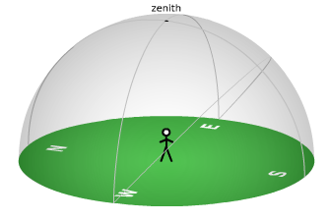
Sunlight

Show the Horizon Diagram panel to illustrate the answer.

5. Draw locations of the moon and observer in the Earth-Moon Geometry diagram and the locations of the sun and moon in the horizon diagram 6 hours later than part #4.
Hide the Horizon Diagram panel.

Sunlight

Earth

Show the Horizon Diagram panel to illustrate the answer.

6. Estimate the angle between the sun and moon in part #5.
No changes are needed to introduce question.

Angle = _________________________
You can check show angle to show the answer. Most students will answer 90º, with “a little bigger than 90º being an optimal answer”.

