ExtraSolar Planets – Student Guide

Background Material
Complete the following sections after reviewing the background pages entitled Introduction, Doppler Shift, Center of Mass, and ExtraSolar Planet Detection.
- Label the positions on the star’s orbit with the letters corresponding to the labeled positions of the radial velocity curve. Remember, the radial velocity is positive when the star is moving away from the earth and negative when the star is moving towards the earth.
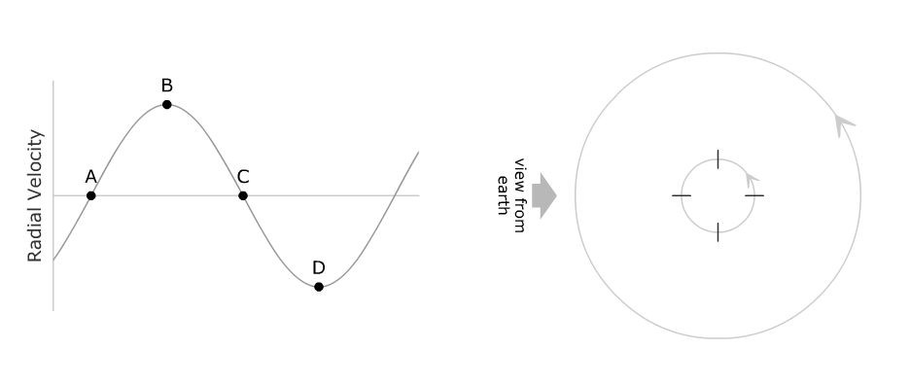
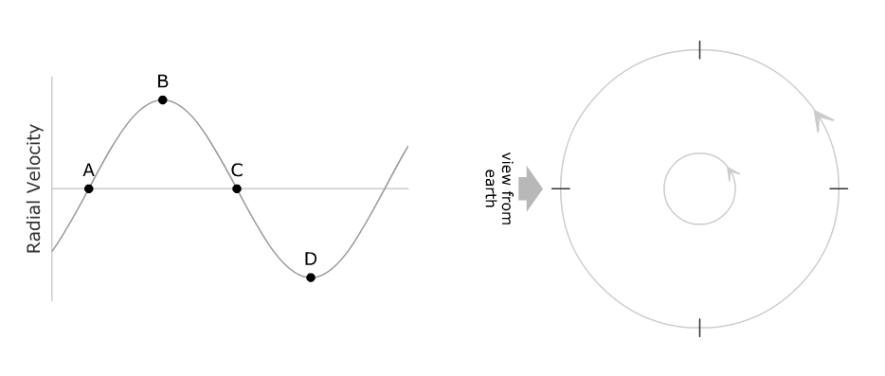
- Label the positions on the planet’s orbit with the letters corresponding to the labeled positions of the radial velocity curve. Hint: the radial velocity in the plot is still that of the star, so for each of the planet positions determine where the star would be and in which direction it would be moving.

Part I: Exoplanet Radial Velocity Simulator

Introduction
Open up the exoplanet radial velocity simulator. You should note that there are several distinct panels:
- a 3D Visualization panel in the upper left where you can see the star and the planet (magnified considerably). Note that the orange arrow labeled earth view shows the perspective from which we view the system.
  - The Visualization Controls panel allows one to check show multiple views. This option expands the 3D Visualization panel so that it shows the system from three additional perspectives:
- a Radial Velocity Curve panel in the upper right where you can see the graph of radial velocity versus phase for the system. The graph has show theoretical curve in default mode. A readout lists the system period and a cursor allows one to measure radial velocity and thus the curve amplitude (the maximum value of radial velocity) on the graph. The scale of the y-axis renormalizes as needed and the phase of perihelion (closest approach to the star) is assigned a phase of zero. Note that the vertical red bar indicates the phase of the system presently displayed in the 3D Visualization panel. This bar can be dragged and the system will update appropriately.
- There are three panels which control system properties.
  - The Star Properties panel allows one to control the mass of the star. Note that the star is constrained to be on the main sequence – so the mass selection also determines the radius and temperature of the star.
  - The Planet Properties panel allows one to select the mass of the planet and the semi-major axis and eccentricity of the orbit.
  - The System Orientation panel controls the two perspective angles.
    - Inclination is the angle between the Earth’s line of sight and the plane of the orbit. Thus, an inclination of 0º corresponds to looking directly down on the plane of the orbit and an inclination of 90º is viewing the orbit on edge.
    - Longitude is the angle between the line of sight and the long axis of an elliptical orbit. Thus, when eccentricity is zero, longitude will not be relevant.
- There are also panels for Animation Controls (start/stop, speed, and phase) and Presets (preconfigured values of the system variables).

Exercises
Select the preset labeled Option A and click set. This will configure a system with the following parameters – inclination: 90º, longitude: 0º, star mass: 1.00 M_{sun}, planet mass: 1.00 M_{jup}, semimajor axis: 1.00 AU, eccentricity: 0 (effectively Jupiter in the Earth’s orbit).
- Describe the radial velocity curve. What is its shape? What is its amplitude? What is the orbital period?

Increase the planet mass to 2.0 M_{jup} and note the effect on the system. Now increase the planet mass to 3.0 M_{jup} and note the effect on the system.
- In general, how does the amplitude of the radial velocity curve change when the mass of the planet is increased? Does the shape change? Explain.

Return the simulator to the values of Option A. Increase the mass of the star to 1.2 M_{sun} and note the effect on the system. Now increase the star mass to 1.4 M_{sun} and note the effect on the system.
- How is the amplitude of the radial velocity curve affected by increasing the star mass? Explain.

Return the simulator to the values of Option A.
- How is the amplitude of the radial velocity curve affected by decreasing the semi-major axis of the planet’s orbit? How is the period of the system affected? Explain.

Return the simulator to the values of Option A so that we can explore the effects of system orientation. It is advantageous to check show multiple views. Note the appearance of the system in the earth view panel for an inclination of 90º.
Decrease the inclination to 75º and note the effect on the system. Continue decreasing inclination to 60º and then to 45º.
- In general, how does decreasing the orbital inclination affect the amplitude and shape of the radial velocity curve? Explain.

- Assuming that systems with greater amplitude are easier to observe are we more likely to observe a system with an inclination near 0° or 90°. Explain.

Return the simulator to Option A. Note the value of the radial velocity curve amplitude. Increase the mass of the planet to 2 M_{Jup} and decrease the inclination to 30°. What is the value of the radial velocity curve amplitude? Can you find other values of inclination and planet mass that yield the same amplitude?
- Suppose the amplitude of the radial velocity curve is known but the inclination of the system is not. Is there enough information to determine the mass of the planet?

- Typically astronomers don’t know the inclination of an exoplanet system. What can astronomers say about a planet's mass even if the inclination is not known? Explain.

Select the preset labeled Option B and click set. This will configure a system with the following parameters – inclination: 90º, longitude: 0º, star mass: 1.00 M_{sun}, planet mass: 1.00 M_{jup}, semimajor axis: 1.00 AU, eccentricity: 0.4. Thus, all parameters are identical to the system used earlier except eccentricity.
In the orbit view box below indicate the earth viewing direction. Sketch the shape of the radial velocity curve in the box at right.
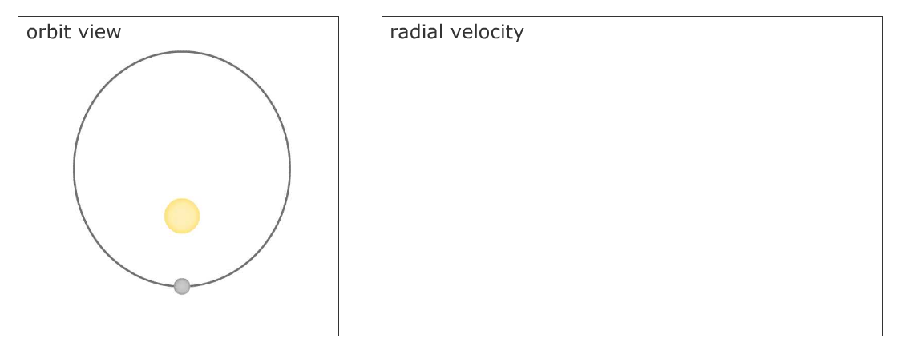
Now set the longitude to 90°. Again indicate the earth’s viewing direction and sketch the shape of the radial velocity curve.
- Does changing the longitude affect the curve in the example above?
- Describe what the longitude parameter means. Does longitude matter if the orbit is circular?

Select the preset labeled HD 39091 b and click set. Note that the radial velocity curve has a sharp peak.
- Determine the exact phase at which the maximum radial velocity occurs for HD 39091 b. Is this at perihelion? Does the minimum radial velocity occur at aphelion? Explain. (Hint: Using the show multiple views option may help you.)
This simulator has the capability to include noisy radial velocity measurements. What we call ‘noise’ in this simulator combines noise due to imperfections in the detector as well as natural variations and ambiguities in the signal. A star is a seething hot ball of gas and not a perfect light source, so there will always be some variation in the signal.
Select the preset labeled Option A and click set once again. Check show simulated measurements, set the noise to 3 m/s, and the number of observations to 50.
- The best ground-based radial velocity measurements have an uncertainty (noise) of about 3 m/s. Do you believe that the theoretical curve could be determined from the measurements in this case? (Advice: check and uncheck the show theoretical curve checkbox and ask yourself whether the curve could reasonably be inferred from the measurements.) Explain.

Select the preset labeled Option C and click set. This preset effectively places the planet Neptune (0.05 M_{Jup}) in the Earth’s orbit.
- Do you believe that the theoretical curve shown could be determined from the observations shown? Explain.

Select the preset labeled Option D and click set. This preset effectively describes the Earth (0.00315 M_{Jup} at 1.0 AU). Set the noise to 1 m/s.
- Suppose that the intrinsic noise in a star’s Doppler shift signal – the noise that we cannot control by building a better detector – is about 1 m/s. How likely are we to detect a planet like the earth using the radial velocity technique? Explain.
You have been running an observing program hunting for extrasolar planets in circular orbits using the radial velocity technique. Suppose that all of the target systems have inclinations of 90°, stars with a mass of 1.0 M_{sun}, and no eccentricity. Your program has been in operation for 8 years and your equipment can make radial velocity measurements with a noise of 3 m/s. Thus, for a detection to occur the radial velocity curve must have a sufficiently large amplitude and the orbital period of the planet should be less than the duration of the project (astronomers usually need to observe several cycles to confirm the existence of the planet). Use the simulator to explore the detectability of each of the following systems. Describe the detectability of the planet by checking Yes, No, or Maybe. If the planet is undetectable, check a reason such as “period too long” or “amplitude too small”. Complete the following table. Two examples have been completed for you.

Mass  (M_{Jup}) | Radius  (AU) | Amplitude  (m/s) | Period  (days) | Detectable  Y N M |  |  | Rationale  A too P too  small big
0.1 | 0.1 | 8.9 | 11 | X
1 | 0.1
5 | 0.1
0.1 | 1
1 | 1
5 | 1
0.1 | 5
1 | 5
5 | 5 | 63.4 | 4070 |  | X |  |  | X
0.1 | 10
1 | 10
5 | 10

- Use the table above to summarize the effectiveness of the radial velocity technique. What types of planets is it effective at finding?

Part II: Exoplanet Transit Simulator

Introduction
Open the exoplanet transit simulator. Note that most of the control panels are identical to those in the radial velocity simulator. However, the panel in the upper right now shows the variations in the total amount of light received from the star. The visualization panel in the upper left shows what the star’s disc would look like from earth if we had a sufficiently powerful telescope. The relative sizes of the star and planet are to scale in this simulator (they were exaggerated for clarity in the radial velocity simulator.) Experiment with the controls until you are comfortable with their functionality.

Exercises
Select Option A and click set. This option configures the simulator for Jupiter in a circular orbit of 1 AU with an inclination of 90°.
- Determine how increasing each of the following variables would affect the depth and duration of the eclipse. (Note: the transit duration is shown underneath the flux plot.)
Radius of the planet:
Semimajor axis:

Mass (and thus, temperature and radius) of the Star:
Inclination:

The Kepler space probe (http://kepler.nasa.gov, scheduled for launch in 2008) will attempt to photometrically detect extrasolar planets during transit. It is predicted to have a photometric accuracy of 1 part in 50,000 (a noise of 0.00002).
- Select Option B and click set. This preset is very similar to the Earth in its orbit. Select show simulated measurements and set the noise to 0.00002. Do you think Kepler will be able to detect Earth-sized planets in transit?
- How long does the eclipse of an earth-like planet take? How much time passes between eclipses? What obstacles would a ground-based mission to detect earth-like planets face?

