Eclipsing Binary Simulator – Student Guide

Background Material
Complete the following section after reviewing the four background pages.
- Crudely describe where the center of mass is located relative to the two stars that make up a binary system.
- Complete the following table related to the location of the center of mass.
Star | Star 1 |  | Star 2 |  | x_{CM}
Star | Mass (M⊙) | x | Mass (M⊙) | x | x_{CM}
System A | 6 | 0 | 6 | 10
System B | 4 | 0 | 2 | 6
System C | 3 | 0 |  | 6 | 4

- If a small O2 spectral type star is completely obscured by a large M4 spectral type star, the drop in total luminosity of the binary system would be best described as …
  - very large
  - around 50%
  - very small
- Complete the following table related to stellar luminosities.
Star | Luminosity (L⊙) | Radius (R⊙) | Temperature(T⊙)
Star A |  | 3 | 1
Star B | 16 |  | 2
Star C |  | ½ | 2

- A grandfather clock starts exactly at noon. Imagine that you make measurements of the height of the tip of the minute hand and create a periodic graph of your data (much like a light curve). If you make an observation at 2:40 pm, what would be the phase of this observation? Explain.

Part I: Exploration with Presets
Open up the eclipsing binary simulator. You should note that there are four distinct panels:
- a 3D Visualization panel in the upper left where you can see the binary system in motion.
- a Light Curve Visualization panel in the upper right where you can see the light variations of the system graphed in either flux or magnitude.
- a Presets panel in the lower left which contains settings to configure the simulator to Student Guide Examples (system configurations selected for their instructional value), Datasets with Complete Parameters (real eclipsing binary light curve data will be displayed and the simulator will be configured so as to mimic this system), and Datasets with Incomplete Parameters (real eclipsing binary light curve data will be displayed and students will be asked to configure the system to match). You can also connect to the Catalogue and Atlas of Eclipsing Binaries site at Eastern University to learn about the binary systems being simulated.
- a Settings panel in the lower right. This panel contains sub-panels that allow you to set the mass, radius, and surface temperature of each star and see their locations on the HR Diagram. There is also a System Properties sub-panel where you can set the semi-major axis, eccentricity, and inclination of the orbit.
You are encouraged to spend some time experimenting with the simulator. However, make sure that you are experimenting in a systematic matter. Make adjustments to one variable exclusively until you develop a good grasp of how it affects the light curve. It is difficult to develop physical intuition if you hop from one variable to another in a haphazard fashion.
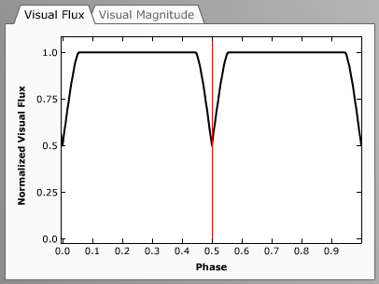
Set the system to Example 1. This preset has stars of the same size, radius, and temperature in circular orbits. Bring the System Properties sub-panel of the Settings panel to the front and click the show the system in motion button. After you have watched the system through several orbits click stop the animation button when the system is near a phase of 0.5 (if the light curve is not exactly at 0.5 you can drag the Light Curve Visualization panel’s vertical red line cursor to the appropriate phase or use the Systems Properties phase slider). This phase represents the instant when one star completely covers the other from the Earth’s perspective. A “pointed” eclipse on a light curve typically reflects a partial eclipse when one star doesn’t completely obscure the other. This system is a special case in that the two stars are exactly the same size so that a total eclipse occurs – yet it only happens for an instant and thus resembles a partial eclipse. Now move the vertical cursor to a phase of 0.25. Note that a large portion of the light curve has this “flat top” reflecting the total luminosity of both stars. This occurs because the two stars are relatively small compared to their separation so an eclipse only occurs for a small fraction of the time.
Figure 1: Light Curve Visualization Panel for Example 1 at phase = 0.5.
Set the system to Example 2. This system is very similar to example #1 except that one star is now twice as big as the other. Note that the eclipses now have flat bottoms corresponding to the time when one star completely eclipses or is encompassed by the other. You should also note that the eclipse depths (the decrease in light level) are much smaller in this system. Whereas Example 1 dropped to a normalized flux of 0.5 during eclipse, the minimum flux here is about 77% of the peak value when both stars are completely visible. However, in both of these examples the eclipse depths for both eclipses are the same.
- Use the vertical red cursor to advance the system to a phase of 0.03. What is the physical significance of this phase?
Set the system to Example 3. The two stars once again have the same mass, same radius, and are in circular orbits, but have different surface temperatures. This causes the eclipse at phase 0.0 to be deeper than the eclipse at phase 0.5. This deeper eclipse is known as the primary eclipse while the shallower is referred to as the secondary eclipse.
- Which star is closer to the Earth during the deeper eclipse? Why?
- What is the depth of the secondary eclipse in visual flux?
Set the system to Example 4. The two stars once again have the same radius, same temperature, and are in circular orbits, but now have different masses. There is no difference between this light curve and that of example #1. We will have to change our vantage point to see the change in the system.
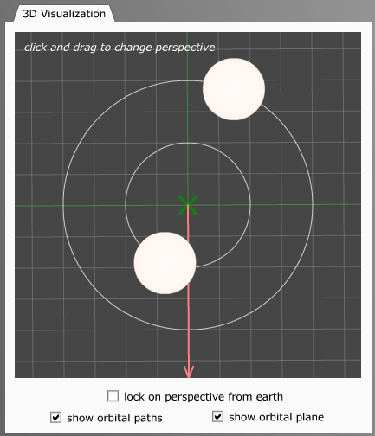
In the 3D Visualization panel deselect lock on perspective from Earth. You may now click and drag anywhere in the 3D Visualization Panel to change the viewer’s perspective. Note that the Lightcurve Visualization panel still illustrates the light curve as detected from the Earth’s perspective. Thus, the 3D Visualization panel is allowing you to leave the Earth and view the system from any vantage point. The red arrow indicates the direction to Earth.
Figure 2: 3D Visualization panel for Example #4 looking down onto the plane of the binary system.
Manipulate the panel until you are looking directly down onto the plane of the binary system as is shown in the figure to the right. The green cross represents the center of mass of the system. You are encouraged to open up the Star 1 Properties sub-panel and play with the mass of Star 1. Note that as the stars’ distances from the center of mass change the mean separation of the stars is still 6R⊙ and the light curve shape is also unchanged.
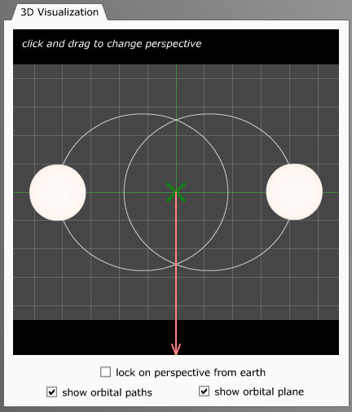
Set the system to Example 5. This example once again has stars of the same size, radius, and temperature but they are now in an elliptical orbit with eccentricity(e) = 0.4. You are still looking down on the plane of the solar system. Click show the system in motion and note that the eclipses no longer occur symmetrically in time. Note that the eclipses on the light curve correspond with the positions when both stars are aligned with the red arrow pointing toward the Earth.
Figure 4: 3D Visualization panel for Example #5 looking down onto the plane of the binary system
Select lock on perspective from Earth and note how the asymmetric occurrence of eclipses appears from this perspective.
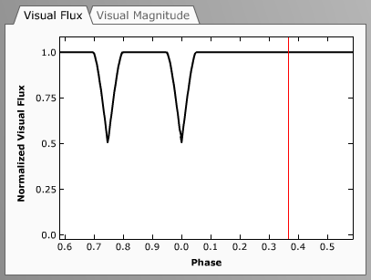
Figure 3: 3D Light curve for Example #5.
Set the system to Example 6 and change your viewpoint so that you are looking down on the plane of the binary system. The stars are still in an elliptical orbit with e = 0.4, but now one star is twice as massive as the other.
- Kepler’s second law describes the behavior of planets in elliptical orbits around the sun. What behavior do you see here similar in nature to Kepler’s second law? (If you increase the eccentricity to 0.6 the effect will be even more pronounced.)
Set the system to Example 7 and select lock on perspective from earth. Note that this system has circular orbits, an inclination of 90°, a separation of 6R⊙, and stars of 3R⊙ and 1R⊙ giving rise to total eclipses. Explore how changing the inclination (with the Systems Properties inclination slider) affects the type of eclipse.
- Decrease the inclination from 90°. Estimate the inclination at which the eclipses become partial.
- Continue to decrease the inclination. At what inclination do the eclipses cease to occur?
Set the system to Example 8. Note that this system also has circular orbits, an inclination of 90°, and stars of 3R⊙ and 1R⊙ but now the separation has been increased to 25R⊙. Explore how changing the inclination affects the type of eclipse.
- Question: Decrease the inclination from 90°. Estimate the inclination at which the eclipses become partial.
- Continue to decrease the inclination. At what inclination do the eclipses cease to occur?
- Based on your experiences with Examples 7 and 8, can you summarize some general guidelines for what types of binary systems are likely to be eclipsing binaries?
Return to Example 2 and click show the system in motion. Note that the two eclipses are “symmetric” in that when Star 1 is closest to the earth the amount of star area obscured is the same as when Star 2 is closest to the earth. The two stars have the same temperature, thus the depths of the two eclipses are identical with this geometry.
Return to Example 3 and click show the system in motion. Note that these two eclipses are also symmetric in that the same amount of star area is obscured in each. However, since the surface temperatures are different the eclipse depths are different as well in this geometry.
Examples 2 and 3 seem to suggest that the eclipses are always symmetric in obscured area. However, this only occurs in the simple cases where eccentricity is zero. When eccentricity is non-zero, the perspective described by the inclination and longitude of the system become important. The longitude of the system is the angle specifying the orientation of the semi-major axes of the orbits relative to your perspective.
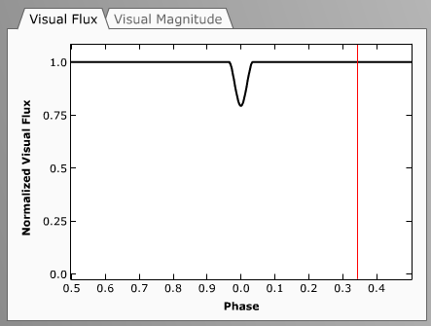
Set the system to Example 5 (where the eccentricity is 0.4). This example presently has two eclipses with equal depths. Go to the Systems Properties sub-panel and decrease the inclination to 75°. Note that with longitude equal to 0° (meaning that our line-of-sight is perpendicular to the semi-major axes of the orbits), the eclipse depths are still equal.
Figure 5: Light curve illustrating only 1 eclipse.
Now experiment with the longitude parameter and note how it affects the light curve. You should be able to identify a range of longitude values for which only one eclipse occurs! Thus, the interplay of inclination, eccentricity, and longitude allow for some very complicated light curves (even in our simplified model).

Part II: Exploring with Real Data
In the previous section we looked at how various aspects of the system affected the light curve. In this section we will reverse the process by exploring real datasets of photometric data and using the simulator to learn about the system from the light curve. However, it should be remembered that there are many parameters involved. Typically light curve information is incorporated with spectra (giving radial velocity curves and spectral type) to give a more complete understanding of system. Without this additional information the system parameters cannot be uniquely determined from the light curve data. Thus, in this lab we will focus on discussing some of the possibilities involved rather than reaching any definitive conclusions on the nature of the system.
It should also be remembered that many approximations are used in this simulator. It assumes that the stellar discs are round and of uniform brightness. This approximation works better for some systems than others.
Let’s look at the photometric data for KP Aql. We can draw a number of conclusions about the system by looking at the light curve:
- Since the two eclipses are evenly spaced in phase (at 0.0 and 0.5) we can conclude that it is likely that the orbit is circular and we can ignore “longitude” effects.
- Since the two eclipses have very similar depths and we are assuming circular geometry (i.e. symmetric eclipses), we can conclude that the two stars have very similar surface temperatures (here both temperatures are 7400 K).
- Since only a small percentage of the light curve is made up of eclipses – most of the light curve consists of the “flat top” – we know that the stars are relatively far apart (KP Aql has a separation 13.61 R⊙, compared to the sizes of the stars.) This is the main reason that our simulator can fit the data so well!
- The fact that the flux falls to very nearly 50% during eclipse is especially significant. For stars of the same temperature and symmetric eclipses, a 50% drop is the largest possible and can only occurs when the two stars are the same size and the inclination must be near 90º. Thus, we are really seeing a total eclipse for a short time. (It is known that KP Aql has an inclination very near 90°and the two stars are very close in size, 1.7 R⊙ and 1.8 R⊙).
The system EW Ori has stars that are widely spaced compared to their size since the eclipses are deep and narrow. And since the secondary eclipse doesn’t occur exactly at phase 0.50 the orbit must be slightly eccentric (e = 0.07). It is difficult to make any firm conclusion related to the uneven depths of the eclipses. If the system has an inclination of exactly 90º, the uneven depths must be due to slight temperature differences in the stars (which is the known case for EW Ori, T₁ = 5970 K and T₂ = 5780 K). However, simply working with the simulator it also possible that if inclination is appreciably less than 90º that longitude could be affecting the eclipses and the stars could have the same temperatures.
Select preset FL Lyr. Once again the two eclipses are evenly spaced in phase (at 0.0 and 0.5) suggesting a circular orbit. This light curve has eclipses of uneven depths, which suggests that the stars are not the same temperature (known values of 6150 K and 5300 K).
The EK Cep system is slightly eccentric from the spacing of the eclipses in phase. However, since the eclipses have very different depths the stars must have very different temperatures.
TW Cas is a circular system that a large temperature difference between two large stars and very wide eclipses! Note that the primary eclipse has “wings” that extend beyond the eclipse predicted by our model.
AD Her has a very striking light curve. The eclipses have very different in depth and are total for a substantial phase interval. This system is a wonderful illustration of the functional dependence of luminosity on radius and surface temperature. The deep eclipse occurs when the hot blue star is obscured. In fact, the eclipse of the orange star is barely noticeable on the light curve.
If you make a small adjustment to the temperature of star 2, you can fit the data more accurately. What is the optimum value of temperature for star 2 (according to the simulator)?
AW UMa consists of two stars in close proximity. This type of system presents complications not handled by our model. The two stars are distorted by each other’s gravity and their surfaces are actually in contact with each other. This is why the theoretical lightcurve shown differs from the real data. AW Lac is another example of an “overcontact system” but with much hotter stars of the same size.
DM Del has stars of different surface temperature in close proximity. This system also demonstrates the limited applicability of the model used here. Due to their close proximity, gravity causes the stars to have ellipsoidal shapes. The surface area of a star which faces the other star also temporarily has a higher temperature invalidating our assumption of uniform disc brightness. There are other more complicated effects as well that are not handled by our simulator.

Part III: Exploring with Real Data
The goal of this section is to give you some feeling for the role of an astronomer who must determine the stellar and system properties of a binary from the light curve data. Photometric data will be provided and you will be asked to use the simulator to create a “matching” light curve.
For each of the following presets most star and system properties will default to minimum values. Properties that do not default to minimum values can be assumed to be correct for the system and are provided to aid you in this task. You should tweak the remaining parameters to match the photometric data as closely as possible. You should specify the “best value” and describe what happens to the light curve as you adjust the free parameters.
- RT CrB – Adjust the radius of star 1.
  - Best Value of Star 1 Radius =
  - Explanation of parameter effect on light curve:
- V478 Cyg – Adjust the inclination.
  - Best Value of inclination =
  - Explanation of parameter effect on light curve:
- V477 Cyg – Adjust the separation.
  - Best Value of separation =
  - Explanation of parameter effect on light curve:
- DI Her – Adjust the eccentricity.
  - Best Value of eccentricity =
  - Explanation of parameter effect on light curve:
- Ag Phe – Adjust the temperature of Star 2. Best Value of Star 2 Temperature = Explanation of parameter effect on light curve:
- Rz Cas – Adjust the temperature of star 2 and the inclination
  - Best Value of Star 2 temperature =
  - Best Value of inclination =
- AF Gem – Adjust the temperature and radius of star 2.
  - Best Value of Star 2 temperature =
  - Best Value of Star 2 radius =

