NAAP InClass Worksheet: Retention of an Atmosphere (Student Version)

- A sample of methane (16 u) gas at a temperature of 300K is placed in an experimental chamber. The graph below shows the distribution of speeds for particles of the gas.
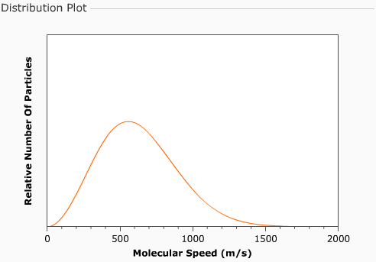

a) Indicate on the plot the most probable velocity (i.e. the speed at which the most particles are moving and write in this value.

b) Next estimate the value of the average velocity and show it on the graph.

c) Indicate the fastest moving 10% of the particles on the graph.

d) An identical amount of helium (4 u) also at 300K is now added to the chamber. Sketch the speed distribution curve for helium.

e) If the walls of the chamber are now configured to allow particles to escape that have a velocity of over 1500 m/s, describe what will happen (i.e. what will the plot look like after time has passed).

f) The chamber once again has the original sample of methane at 300K. Draw in the new speed distribution curve, if the temperature of the methane is lowered to 100K.
2. You can now see a graph of speed (km/s) vs. temperature (K) known as a gas retention plot. Note that speed may represent the escape speed of a planet (a point on the graph) or the average speed of a gas (a curve on the plot).
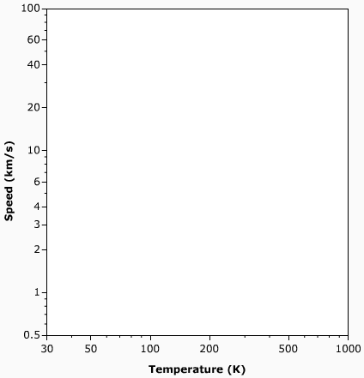
a) The Earth has an escape velocity of 11.2 km/s and an average surface temperature of about 280 K. Indicate the location of the Earth on the plot.

b) Draw in a small region representing where terrestrial planets would be found.

c) Draw in a small region representing where jovian planets would be found.

d) Add the following satellites to the graph:
-- the moon has an escape velocity of 2.4 km/s and a temperature similar to the Earth’s
-- Titan (satellite of Saturn) similar in mass and radius to the moon

Gases are shown on the plot as dashed lines at ten times their average velocity as a function of temperature. Regions on the plot with greater velocities are shown as a solid color. A solar system body can retain a gas over billions of years if its escape velocity is more than ten times the average velocity of the gas. The coloring fades to white at 6 times the average velocity. A solar system body will rapidly loose a gas if its escape velocity is less than 6 times the average velocity.

e) The dashed line on the graph now shows the 10 × v_{avg} curve for hydrogen. Which solar system bodies will clearly be able to retain hydrogen over long periods of time?

f) The 10 × v_{avg} curve for nitrogen is now shown. Which solar system bodies will clearly NOT be able to retain nitrogen over long periods of time?

g) Devise a procedure for using this simulator to determine the minimum size of an asteroid in the main asteroid below that could retain water vapor over long periods of time?

