NAAP InClass Worksheet: Retention of an Atmosphere (Instructor Version)

- A sample of methane (16 u) gas at a temperature of 300K is placed in an experimental chamber. The graph below shows the distribution of speeds for particles of the gas.
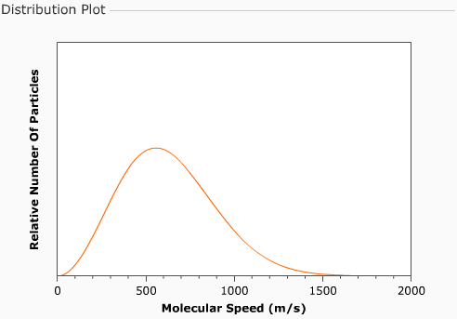
Start the Gas Retention Simulator and use the select gas to add pull-down menu to add methane. The temperature should be 300K by default.

a) Indicate on the plot the most probable velocity (i.e. the speed
Click show draggable cursor and drag the cursor to the peak of the speed curve. This should indicate a speed of about 555 m/s.
at which the most particles are moving and write in this value.

Select methane in the Gases panel and click show distribution info for selected gas. Drag the cursor (to the right) until 50% of the gas is on each side (about 600 m/s). Point out that the curve is not symmetric.
b) Next estimate the value of the average velocity
and show it on the graph.

Drag the cursor (further to the right) until only 10% of the gas is on the right side (about 980 m/s). Point out to students the high speed region under the curve.
c) Indicate the fastest moving 10% of the particles on the graph.

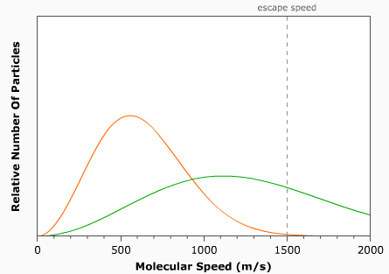
d) An identical amount of helium (4 u) also at 300K is now added
to the chamber. Sketch the speed distribution curve for helium.
Unclick show draggable cursor and use the select gas to add pull-down menu to add helium. You may wish to click start simulation button so they can see the difference in gas particle speed. Click Stop simulation when finished.

e) If the walls of the chamber are now configured to allow particles to escape that have a velocity of over 1500 m/s, describe what will happen (i.e. what will the plot look like after time has passed).
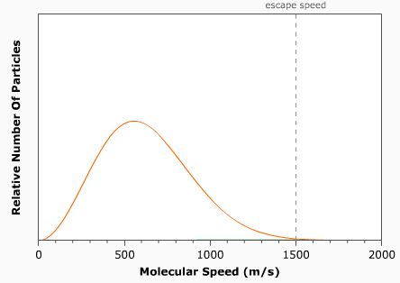
Click allow escape from chamber and point out to students the location of the escape speed on the speed distribution plot. Then click the start simulation button. They should see the helium particles rapidly escape while the methane is relatively unchanged. Point out to students that it is the fastest particles that are escaping, yet the curve still reflects a true speed distribution. The simulation assumes that the timescale of redistribution is much smaller than the escape timescale. You should ask students if some methane escaped as well.

Select helium in the Gases menu and click remove selected gas and then click reset proportions. You now have the original sample of methane again.

f) The chamber once again has the original sample of methane at 300K. Draw in the new speed distribution curve, if the temperature of the methane is lowered to 100K.
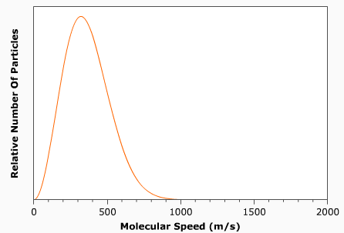
Drag the temperature slider to 100 K and point out the changes in the speed curve – value of peak and shape of curve. You may want to move between the 100K and 300 K values and note the changes. You may also wish to run the simulations (with allow escape from chamber unselected) so that students can see the change in speed distribution.

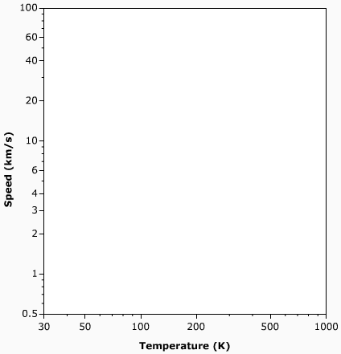
2. You can now see a graph of speed (km/s) vs. temperature (K) known as a gas retention plot. Note that speed may represent the escape speed of a planet (a point on the graph) or the average speed of a gas (a curve on the plot).

a) The Earth has an escape velocity of 11.2 km/s and an average surface temperature of about 280 K. Indicate the location of the Earth on the plot.
Display the Gas Retention Plot. Drag the hot point (red circle) to a speed of 11.2 km/s and a temperature of 280 K which represent the Earth.

b) Draw in a small region representing where terrestrial planets would be found.
Click the Plot Option show terrestrial planets.

c) Draw in a small region representing where jovian planets would be found.
Students may need hints regarding temperature and size. Click the Plot Option show jovian planets.
d) Add the following satellites to the graph:
-- the moon which has an escape velocity of 2.4 km/s and a temperature similar to the Earth’s, and
-- Titan (a satellite of Saturn) similar in mass and radius to the moon
Click the Plot Option show icy bodies and moons. Explain that the moon can be located on the graph by moving down from the Earth’s location (temperature) to a speed of 2.4 km/s. Titan can then be located by assuming that it has similar mass and size as the moon and thus has the same escape velocity and has the same temperature as Saturn. So move left from the moon’s position until you are at beneath Saturn on the graph.

Gases are shown on the plot as dashed lines at ten times their average velocity as a function of temperature. Regions on the plot with greater velocities are shown as a solid color. A solar system body can retain a gas over billions of years if its escape velocity is more than ten times the average velocity of the gas. The coloring fades to white at 6 times the average velocity. A solar system body will rapidly loose a gas if its escape velocity is less than 6 times the average velocity.
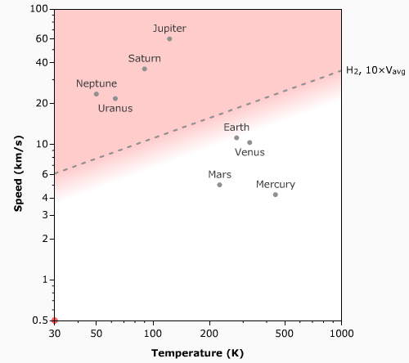
Unclick show icy bodies and moons leaving just planets showing. Then check hydrogen in the Gases panel.

e) The dashed line on the graph now shows the 10 × v_{avg} curve for hydrogen. Which planets will clearly be able to retain hydrogen over long periods of time?
Point out that the Jovian planets are clearly above the hydrogen curve and can thus can retain hydrogen for long periods of time.

Then uncheck hydrogen in the Gases panel and check nitrogen.

f) The 10 × v_{avg} curve for nitrogen is now shown. Which planets will clearly NOT be able to retain nitrogen over long periods of time?
Point out that only Mercury is below the 10 × v_{avg} and the 6 × v_{avg} line. Thus, Mercury and cannot hold on to nitrogen for very long.

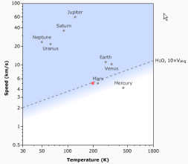
g) Devise a procedure for using this simulator to determine the minimum size of an asteroid in the main asteroid below that could retain water vapor over long periods of time?
Instructors should give students several minutes to think about this individually or in groups and then query the class for suggestions on the procedure and work through it.

First uncheck nitrogen in the Gases panel and check water. Note that the asteroid belt is in between Mars and Jupiter corresponding to a temperature of about 200K. So drag the hot point (or use the slider) to a temperature of about 200K near the bottom of the chart. Asteroid densities vary considerably, but let’s assume a value slightly less than the density of Mars, say 3.0 g/cm³ and use the slider to set this value. Now we can increase the radius of the asteroid until it hits the 10 × v_{avg} line for water vapor. This indicates a radius of about 3900 km which is much larger than the size of the largest asteroids.

