Solar System Models – Pretest

Answer the following questions.
- Ptolemy introduced _________ to help explain retrograde motion.
  - epicycles
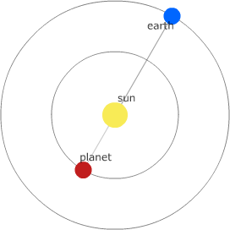
  - circular orbits
  - parabolas
  - hyperbolas
  - ellipses
- What is the configuration shown?
  - Greatest Elongation
  - Inferior Conjunction
  - Superior Conjunction
- When a superior planet is on the far side of the Sun at an elongation of 0°, the planet is said to be at
  - conjunction
  - aphelion
  - opposition
  - perihelion
  - quadrature
- When Venus is directly on the far side of the Sun, it is at
  - superior conjunction
  - inferior conjunction
  - opposition
  - greatest elongation
  - quadrature
- How long does it take a planet to orbit the sun exactly once?
  - Sidereal period
  - Synodic period
  - One rotation
  - One day
- The planet Mars is seen directly over the south point of the horizon at exactly midnight. The time interval until the next instance of this occurrence is
  - the synodic period of the Earth
  - the synodic period of Mars
  - the rotational period of the Earth
  - the sidereal period of Mars
  - the sidereal period of the Earth
- Stars rise in the east and set in the west. If a planet undergoing retrograde motion is near certain star, where will the planet be the following evening?
  - It will remain in the same spot with respect to that star.
  - A small bit east of that star.
  - A small bit west of that star.
- Based solely on the order of the planets, which planet has a shorter sidereal period, Mercury or Mars?
  - Mercury
  - Mars
- The best configuration in which to observe a superior planet is at
  - superior conjunction
  - inferior conjunction
  - greatest elongation
  - quadrature
  - opposition

