Solar System Models – Posttest

Answer the following questions.
- What kind of planet is a inferior planet?
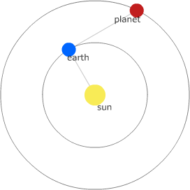
  - Those planets closer to the sun than the earth.
  - Those planets farther from the sun than the earth.
- What is the configuration shown?
  - Quadrature
  - Conjunction
  - Opposition
- When an inferior planet is as far from the Sun (in angular seperation) as it ever gets, the planet is said to be at
  - inferior conjunction
  - opposition
  - greatest elongation
  - superior conjunction
  - quadrature
- When Mars is seen on the eastern horizon at midnight, it is near
  - quadrature
  - inferior conjunction
  - opposition
  - superior conjunction
  - greatest elongation
- Querron the Vegan peers out of his flying saucer window down upon the plane of our solar system and sees the Sun, the Earth, and Jupiter exactly aligned. How long will the Querron would have to wait until the Earth returns to the same spot?
  - the synodic period of Jupiter
  - the sidereal period of the Earth
  - the rotational period of the Earth
  - the sidereal period of Jupiter
  - the synodic period of the Earth
- The planet Mars is seen directly over the south point of the horizon at exactly midnight. The time interval until the next instance of this occurrence is
  - the synodic period of the Earth
  - the synodic period of Mars
  - the rotational period of the Earth
  - the sidereal period of Mars
  - the sidereal period of the Earth
- Stars rise in the east and set in the west. If a planet undergoing prograde motion is near certain star, where will the planet be the following evening?
  - A small bit east of that star.
  - It will remain in the same spot with respect to that star.
  - A small bit west of that star.
- What happens to the synodic period of a planet if it is moved closer to the earth?
  - The synodic period would be longer.
  - The synodic period would remain unchanged.
  - The synodic period would be shorter.
- Which of the following configurations has the largest value of elongation?
  - Mercury at superior conjunction
  - Mars at conjunction
  - Mercury at greatest elongation
  - Venus at superior conjunction
  - Venus at greatest elongation

