Planetary Orbit Simulator – Posttest

Answer the following questions.
- Which of the following is not part of Kepler's contribution to planetary orbits?
  - shapes of the orbit
  - speeds of planets in their orbit
  - orbital period
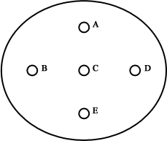
  - gravity
- Which point or points in the figure to the right is a focus of the ellipse?
  - A, E
  - C
  - B, D
  - B, C, D
  - A, C, E
- In an orbit, the planet is almost always
  - moving directly away from the sun.
  - moving directly towards the sun.
  - neither moving away nor towards the sun.
  - moving in a random direction.
- The speed of a planet in orbit is
  - constant.
  - always speeding up, but barely noticeable.
  - always slowing down, but barely noticeable.
  - sometimes speeding up and sometimes slowing down.
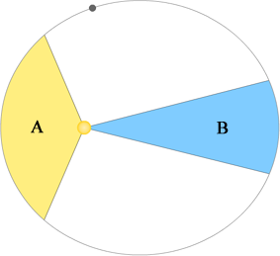
- The areas in regions A and B are equal in size. Which of the following statements are true?
  - The orbital path length subtended by region A is longer than that given by region B. Therefore it will take the planet longer to move through region A.
  - The planet will cover the distances subtended by regions A and B in equal amounts of time because the planet moves faster through region A than region B.
  - The planet will take longer to move through region B because it is moving slower in region B than it is in region A.
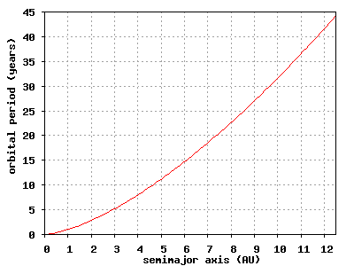
- If a planet has an orbital radius four times earth's, what will its period be?
  - half as large
  - the same
  - four times as much
  - eight times as much
  - none of the above
- Which of the orbital distances below correspond to an eccentricity of 0.1?
  - 0.5 AU
  - 1 AU
  - 4 AU
  - 13.6 AU
  - all of the choices are physically possible
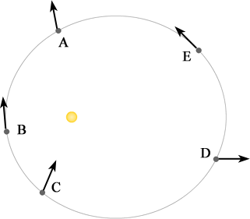
- If the arrows depicted in the picture represent acceleration, which planet or planets is shown correctly? (Planets can be orbiting either clockwise or counterclockwise.)
  - A
  - C
  - D
  - B, E
  - A, C
- If the arrows depicted in the picture represent velocity, which planet or planets is shown correctly? (Planets can be orbiting either clockwise or counterclockwise.)
  - A
  - C
  - D
  - B, E
- If a planet has a semimajor axis of 6 and an eccentricity of 0.1, how far is the planet at [aphelion/perihelion]?
  - 0.6
  - 5.4
  - 5.9
  - 6.1
  - 6.6
  - 60

