Motions of the Sun – Pretest

Answer the following questions.
- The sun rises lowest ( its maximum altitude during the day is smallest) in our sky (assume a mid United States latitude) on …
  - March 21
  - June 21
  - September 21
  - December 21
- At which of the following latitudes can an observer see the sun at their zenith on October 18?
  - 20° N
  - 10° N
  - 0°
  - 10° S
  - 20° S
- On the vernal equinox the sun sets directly west. Where will the sun set two weeks later?
  - north of west
  - south of west
- On which of the following dates will an observer at 85° N see the sun above the horizon all day long?
  - June 21
  - December 21
  - The sun will rise and set everyday of the year at this latitude.
- From Tampa, FL (lat = 28°N), the meridinal altitude of the star Sirius (dec=-16°) is:
- From Lincoln, NE, (lat=41°N), the meridinal altitude of the sun on the autumnal equinox is:
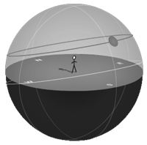
- The horizon diagram below shows the path of the sun on the ____________ from a latitude of 75°N.
  - summer solstice
  - autumnal equinox
  - winter solstice

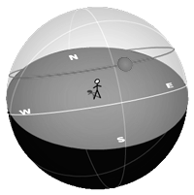
- The horizon diagram below shows the path of the sun on the summer solstice from a latitude of _____________.
  - 0°
  - 30° N
  - 60° N
  - 90° N

