The Rotating Sky – Pretest

Answer the following questions.
- How much of the celestial sphere is visible for an observer at 0° S at any one instance? %

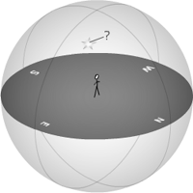
- To the nearest 30°, what is the altitude of the star shown to the right?

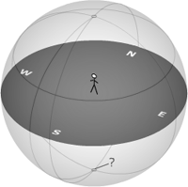
- What is the coordinate feature indicated to the right?
  - Zenith
  - Nadir
  - Meridian
  - Vertical Circle
  - Circle of constant altitude

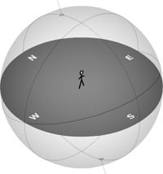
- What is the latitude of the observer in the horizon diagram to the right? (Circle N or S)
  - 0°
  - 20° N / S
  - 45° N / S
  - 75° N / S
  - 90° N / S

- The observer is looking east. Where is the observer?
  - north pole
  - mid northern latitude
  - equator
  - mid southern latitude
  - south pole

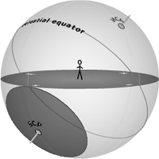
- What region is indicated by the shaded region?
  - Circumpolar
  - Rise and Set
  - Never-rise

- What is the rise and set declination range for an observer at 40° N?
__________ to __________

- An observer at 15° S will see predominately what type of star?
  - rise and set
  - circumpolar
  - never-rise

