Basic Coordinates & Seasons – Pretest

Answer the following questions.
- Which of the following coordinates or coordinate feature does NOT belong to the Celestial Equatorial Coordinate System?
  - North Celestial Pole
  - 0 Hour Circle
  - Celestial Equator
  - Latitude
  - Right Ascension
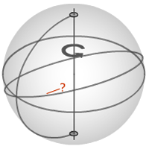
- What is the name of the coordinate feature indicated in the figure to the right?
  - North Celestial Pole
  - 0 Hour Circle
  - Celestial Equator
  - South Celestial Pole
  - Ecliptic
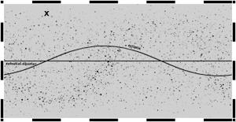
- To the nearest 15°, what is the declination of the coordinate shown?
- A star is at 9 h, 45°. What will the coordinate of the star be 12 hours from now?
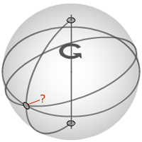
- What is the Seasonal Point shown to the right?
  - Vernal Equinox
  - Summer Solstice
  - Autumnal Equinox
  - Winter Solstice
  - None of the Above

- Circle all of the following to which the number 23.5 has relevance.
  - The angle between the north celestial pole and the earth's north pole
  - The angle between the north celestial pole and the axis of the earth's rotation about the sun
  - The maximum declination of the sun
  - The declination of the north celestial pole
  - The angle between the celestial equator and the ecliptic
- A particular observer sees almost no shadow from a stick in the ground at noon on June 21. Where is the observer?
  - Very near the Tropic of Cancer
  - Somewhere between the Tropic of Cancer and the Equator
  - Very near the equator
  - Somewhere between the Equator and the Tropic of Capricorn
  - Very near the Tropic of Capricorn
- Circle all of the following which are a significant factor in the summer months being hotter (for the northern hemisphere).
  - The sun rays are more direct and thus felt more intensely
  - The length of time the sun in the sky is longer than average
  - The sun is more actively magnetically during the summer
  - The northern hemisphere of the earth is tilted towards the sun
  - The earth is closer to the sun during the summer
  - The earth slows down in its orbit during the summer

- The image below shows lines that all have the same value of what coordinate?
  - longitude
  - latitude
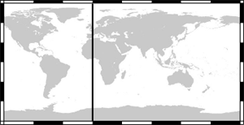
- What is the name of the line shown below?
  - Prime Meridian
  - Not a named line
  - International Date Line

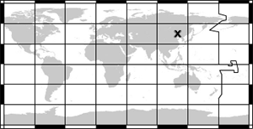
- To the nearest 15°, the x is at approximately what latitude coordinate?

- What is the value of 43.75° in degrees and minutes?

