Basic Coordinates & Seasons – Posttest

Answer the following questions.
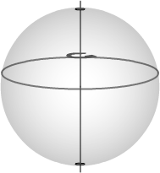
- The image to the right shows a line that all have the same value of what coordinate?
  - right ascension
  - declination
  - neither

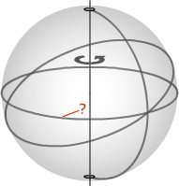
- What is the name of the coordinate feature indicated in the figure to the right?
  - North Celestial Pole
  - 0 Hour Circle
  - Celestial Equator
  - South Celestial Pole
  - Ecliptic

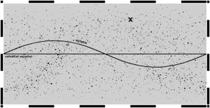
- To the nearest 3 h, what is the right ascension of the coordinate shown?

- A star is at 12 h, -60°. What will the coordinate of the star be 18 hours from now?
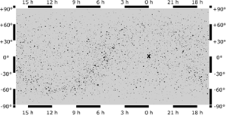
- What is the Seasonal Point shown to the right?
  - Vernal Equinox
  - Summer Solstice
  - Autumnal Equinox
  - Winter Solstice
  - None of the Above

- Circle all of the following that are a description applicable to the ecliptic.
  - The plane which the solar system orbits in the Milky Way
  - The plane in which the earth orbits the sun
  - The plane extending to infinity from the earth's equator
  - The path the sun travels in the celestial sphere
  - The plane tangent to the earth's surface at the point of the observer

- If the sun sets south of west for an observer in the southern hemisphere, which of the following is true?
  - The sun will be in the sky longer than 12 hours.
  - The sun will be in the sky less than 12 hours.
  - The sun will be in the sky for (almost exactly) 12 hours.

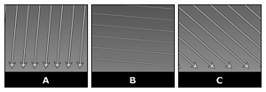
- Which surface is most efficiently receiving energy from the sun?
  - A
  - B
  - C
  - They are all equal
- What is the zero point or line for longitude?
  - Prime Meridian
  - International Date Line
  - Equator
  - North Pole
  - South Pole
  - Observer's current location

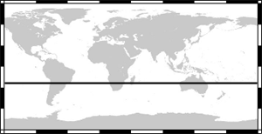
- What is the name of the line shown to the right?
  - Tropic Capricorn
  - Antarctic Circle
  - Tropic of Cancer
  - Arctic Circle
  - Equator

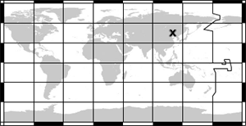
- To the nearest 15°, the x is at approximately what longitude coordinate?

- Which values of 38°15’ in decimal notation?

