Lunar Phase Simulator – Assessment Questions
- The moon depicted here is what phase.
  - waxing crescent
  - first quarter
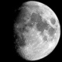
  - waxing gibbous
  - waning gibbous
  - third quarter
  - waning crescent
- If a moon is between 50% and 100% illuminated it is a…
  - crescent moon.
  - gibbous moon.
  - new moon.
  - full moon.
- During a new moon what percent of the moon’s entire surface (irrespective of how much we can see) is illuminated by the sun?
  - 0%
  - 25%
  - 50%
  - 75%
  - 100%
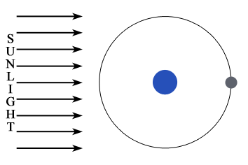
- What is the phase of the moon depicted above?
  - new
  - first quarter
  - third quarter
  - full
- If the moon is at its highest point at 12 AM…
  - it rose at about 6 AM and will set at about 6 PM.
  - it rose at about 6 PM and will at about 6 AM.
  - it did not rise earlier, it was always in the observer’s sky that day.
  - it rose earlier at 12 PM and will set the following 12 PM.
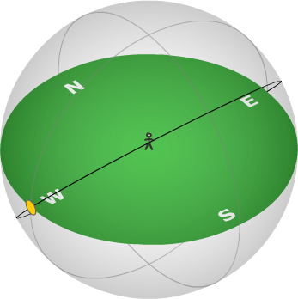
- What is the time of day depicted in the figure to the right?
  - 12 AM
  - 6 AM
  - 12 PM
sun
  - 6 PM
- If it is noon and a new moon for a particular observer a second observer on the opposite of the earth
  - will see a full moon.
  - will see a new moon.
  - won’t see any moon in the sky at all.
- During the course of an evening…
  - the moon basically stays at the same phase.
  - the moon will go through 2 phases.
  - the moon will go through 3 phases.
  - the moon will go through all 8 phases.
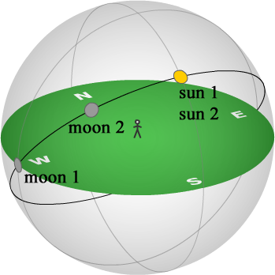
- Approximately how much time has elapsed between moon 1 and moon 2 in the figure above?
  - 3 hours
  - 6 hours
  - 1 day
  - 4 days
  - 7 days
  - 14 days
- Over the course of a month, about how much of the moon’s surface can be photographed?
  - 25%
  - 50%
  - 75%
  - 100%

