Lunar Phase Simulator – Assessment Questions
- The moon depicted here is what phase.
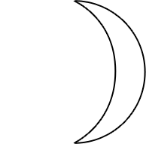
  - waxing crescent
  - first quarter
  - waxing gibbous
  - waning gibbous
  - third quarter
- If the moon is illuminated on the left-hand side it is…
  - waxing.
  - waning.
- During the first quarter phase, how much of the face of the moon that we see is illuminated by the sun?
  - 0%
  - 25%
  - 50%
  - 75%
  - 100%
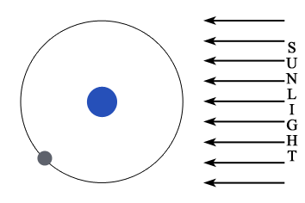
- What is the phase of the moon depicted above? [randomize over they four selections below]

  - 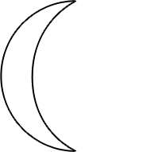
  - 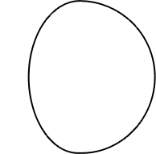
  - 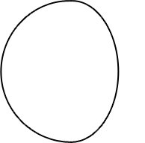

- What time of day is the new moon highest?
  - 12 AM
  - 6 AM
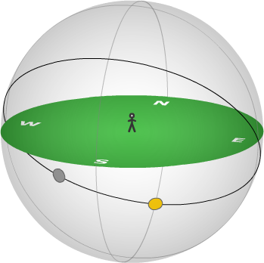
  - 12 PM
  - 6 PM
- Is the moon in the figure to the right currently visible to the observer?
  - yes
moon
  - no
sun
- Which of the following best estimate the time period between new moon and new moon?
  - 7 days
  - 14 days
  - 28 days
  - 30 days
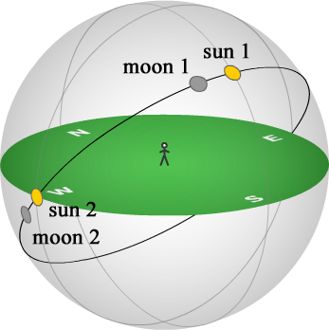
- Approximately how much time has elapsed between moon 1 and moon 2 in the figure above?
  - 3 hours
  - 6 hours
  - 1 day
  - 4 days
  - 7 days
  - 14 days
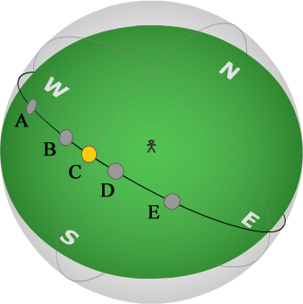
- Relative to a new moon at noon, what was the moon’s position 3 days earlier?
  - A
  - B
  - C
  - D
  - E
- For a lunar eclipse (the moon is obscured from view), which phase is necessary?
  - new moon
  - first quarter
  - full moon
  - third quarter

