Eclipsing Binary Simulator – Pretest

Answer the following questions.
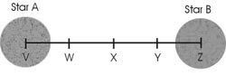
- If Star A has a mass of 3 M⊙ and star B has a mass of 1 M⊙, the center of mass will be at which letter position?

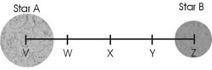
- If Star A has a mass of 3 M⊙ and the center of mass is at position W, what is the mass of star B? M⊙

- A red star would have a surface temperature of …
  - 3,000 K.
  - 10,000 K.
  - 4,500 K.
  - 6,000 K.
  - 20,000 K.

- If a yellow giant star has the same surface temperature as the sun (T = T⊙) and a radius twice that of the sun (R = 2R⊙), what will its luminosity be?
L⊙

- A grandfather clock starts exactly at noon. Imagine that you make measurements of the height of the tip of the minute hand and create a periodic graph of your data (much like a light curve). If you make an observation at 1:30 pm, what would be the phase of this observation?
  - 0.000
  - 0.250
  - 0.333
  - 0.500
  - 0.750
- The binary system below has an inclination of 90°. What type of eclipse will be seen when the orange star A in front of the yellow star B?
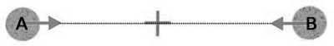
  - a deep, flat eclipse
  - a shallow, pointed eclipse
  - a deep, pointed eclipse
  - a shallow, flat eclipse

- A binary system is most likely to be an eclipsing binary if it has …
  - small inclination and small stellar radii.
  - large inclination and small stellar radii.
  - small inclination and large stellar radii.
  - large inclination and large stellar radii.

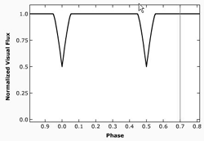
- From the eclipsing binary light curve shown the right, one can conclude that the stars have circular orbits and ...
  - the same surface temperatures and radii.
  - different surface temperatures and different radii.
  - the same radii but different surface temperatures.
  - the same surface temperatures but different radii.

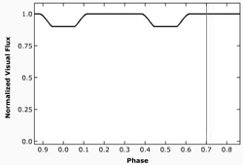
- From the eclipsing binary light curve shown to the right, one can conclude that the stars ...
  - have a small separation compared to their radii.
  - have a large separation compared to their radii.

