Blackbody Curves & UBV Filters – Pretest

Answer the following questions:
- Which of the following is a blackbody curve?

  - 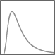
  - 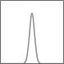
  - 
  - 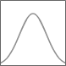

- Which of the following is not part of the electromagnetic spectrum?
  - the light from an incandescent light bulb
  - the radiation produced in a microwave oven
  - the heat from the heating coils in a conventional oven
  - the radiation used to take an x-ray of bones
  - all of the above are part of the electromagnetic spectrum
  - none of the above are part of the electromagnetic spectrum

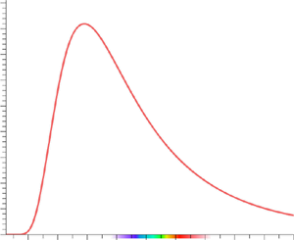
- The blackbody curve for an object at T = 10,000 K is shown in the figure. If the temperature is lowered to 7,500 K…
  - the area under the curve decreases and the peak shifts to the right.
  - the area under the curve increases and the peak shifts to the left.
  - the area under the curve increases and the peak shifts to the right.
  - the area under the curve decreases and the peak shifts to the left.

- How does the color of a star compare to the sun if it is significantly colder than the sun?
  - blue
  - redder
  - basically the same color

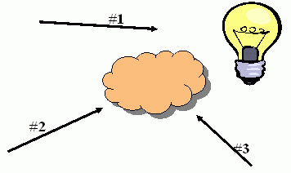
- To the right is a hot blackbody source represented by the light bulb. The cloud is a cool, low density gas. What type of spectra would an observer looking from the perspective labeled #3 see?
  - continuous
  - emission
  - absorption

- What is the central wavelength of a red filter?
  - 350 nm
  - 440 nm
  - 530 nm
  - 600 nm
  - 750 nm

- Which of the following is NOT an example of a filter?
  - suit and tie required for entrance into a restaurant
  - parole board for convicted felons
  - language censor for public broadcast television
  - a measuring cup for cooking
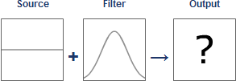
- Which output below goes with the setup above?

  - 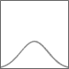
  - 
  - 

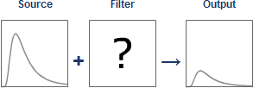
- Which filter below goes with the setup above?

  - 
  - 