Blackbody Curves & UBV Filters – Posttest

Answer the following questions:
- Which of the following is a blackbody curve?

  - 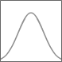
  - 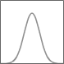
  - 
  - 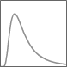

- Which term describes how much energy per unit time a light source emits (from the observer's perspective)?
  - color
  - frequency
  - wavelength
  - blackbody
  - intensity

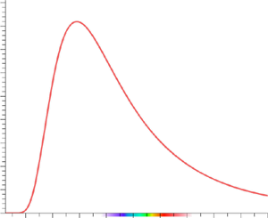
- The blackbody curve for an object at T = 10,000 K is shown in the figure. If the temperature is lowered to 5,000 K…
  - the area under the curve is halved and the peak wavelength is halved.
  - the area under the curve is halved and the peak wavelength doubles.
  - the area under the curve decreases by a factor of 16 and the peak wavelength doubles.
  - the area under the curve decreases by a factor of 16 and the peak wavelength is halved.
- If a star is redder than the sun, how does the temperature of the star compare to the sun?
  - higher temperature
  - colder temperature
  - basically the same temperature

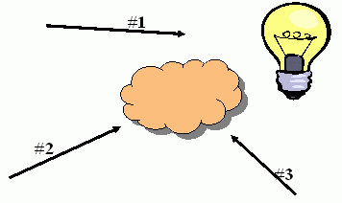
- To the right is a hot blackbody source represented by the light bulb. The cloud is a cool, low density gas. What type of spectra would an observer looking from the perspective labeled #2 see?
  - continuous
  - emission
  - absorption

- Which of the following filter would have a central wavelength of 600 nm?
  - ultraviolet
  - blue
  - visible (green)
  - red
  - infrared

- To get a good response, that is a strong measurement, from a very cool star, what kind of filters would be most useful?
  - a filter which lets blue light pass through
  - a filter which lets red light pass through
  - a filter which lets green light pass through
  - a filter which lets ultraviolet light pass through

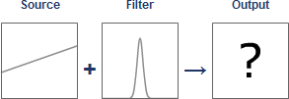
- Which output below goes with the setup above?

  - 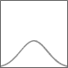
  - 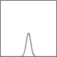
  - 

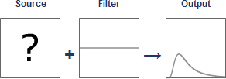
- Which source below goes with the setup above?

  - 

