Atmospheric Retention – Posttest

Answer the following questions.
- If a particle is launched from the surface of the earth with a velocity of 18 km/s, what happens to the particle?
  - It will go up and keep on going, never coming back down.
  - It will go up, but must come down.
  - It will go up with just enough speed to not come back down.
- Planet A has a mass M and radius R. Planet B has a mass 2 M and a radius 1 R. How do the escape velocities of the two planets compare?
  - Planet B's escape velocity is less than planet A's escape velocity
  - Planet B's escape velocity is equal to planet A's escape velocity
  - Planet B's escape velocity is greater than planet A's escape velocity
- Which of the following looks most like the distribution one would expect for the speeds of gases at a particular temperature?





- What fraction of particles will have a speed greater than the average speed?
  - more than half of the particles
  - less than half of the particles
  - exactly half of the particles
- How does the average kinetic energy depend on temperature?
  - K ∝ T²
  - K ∝ T
  - K ∝ 1/T
  - K ∝ 1/T²

- All three gases have the same mass. Which gas is has the lowest temperature?
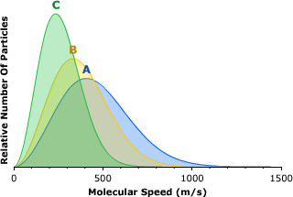
- Which gas is most easily retained?
  - NH₃
  - CO₂
  - He
- All of the bodies below have reasonably close escape velocities. Which has an atmosphere?
  - Mercury
  - Moon
  - Titan

