Processor selection

Embedded Systems Properties:
- Well bounded task
- Highly optimized
- Example: four-bit micro controller on the coffee machine

Selection criteria
- Availability in suitable implementation
- Capability to deliver acceptable performance
- Supported by suitable operating systems
- Supported by appropriate and adequate tools

Suitable Implementation
- Dell optiplex versus Dell dimension
- Product availability
- Cost sensitivity versus performance sensitivity
Acceptable Performance
- Not the computational power but the fit between architecture and the required tasks
- Benchmark alone may not yield enough insights; detailed task characterization is needed
Supported Appropriate OS
- Kernel porting is not trivial so choose wisely
- MicroC/OS II, VxWorks, MicroC-Linux, Windows CE
Supported by Adequate Tools
- Cross compiler and debugging support
- Instruction set simulator
Misc. Consideration
- Product familiarity
- Corporate commitment or industrial preference

Packaging

Microprocessor versus Microcontroller

Benefits of using microcontrollers
- Lower cost
- More reliable
- Better performance
- Faster (on-chip signals)
- Lower RF signatures
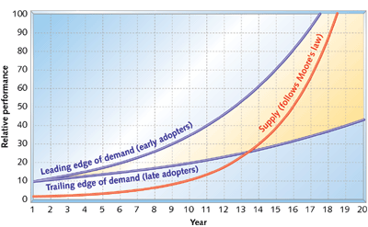a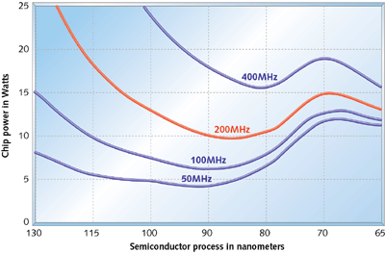
Active power

