Case-Based Reasoning:
Foundational Issues, Methodological Variations,
and System Approaches

Agnar Aamodt, Enric Plaza

AI Communications, March 1994

Presentation by
Praveen Guddeti
March 25, 2002

Outline:
- Introduction.
- History of the CBR field.
- Fundamentals of CBR methods:
- Main types of CBR methods.
- A descriptive framework.
- The CBR cycle.
- A hierarchy of CBR tasks.
- CBR problem areas.

- Representation of cases.
- The Dynamic Memory Model.
- The Category and Exemplar Model.
- Case Retrieval.
- Case Reuse.
- Case Revision.
- Case Retainment – Learning.
- Integrated Approaches.
- Applications.
- Tools.
- Conclusions and Future Trends.

What is Case-Based Reasoning (CBR)?

- Case-based reasoning is […] reasoning by remembering.

Leake, 1996

- A case-based reasoner solves new problems by
adapting solutions that were used to solve old
problems.

Riesbeck & Schank, 1989

- Case-based reasoning is both […] the ways
people use cases to solve problems and the
ways we can make machines use them.

Kolodner,1993

Case-Based Reasoning is….
- A methodology to model human reasoning and thinking.
- A methodology for building intelligent computer systems.
- A cyclic and integrated process for solving a problem.
- An approach to incremental, sustained learning.

CBR in a nutshell:
- Retrieve similar experiences about similar situations from the memory.
- Reuse the experience in the context of the new situation: complete or partial reuse, or adapt according to differences.
- Store new experience in memory (learning)

History of the CBR field:
- Roots of case-based reasoning in AI:
- Theories of concept formation, problem solving and experiential learning within philosophy and psychology.
- The study of analogical reasoning.
- The works of Roger Schank on dynamic memory and the central role that a reminding of earlier situations and situation patterns have in problem solving and learning.

- Originated in the US.
- CYRUS system was the first CBR system. It was basically a question-answering system having knowledge of the various travels and meetings of former US Secretary of State Cyrus Vance.
- PROTOS system for classification of tasks.
- GREBE, HYPO and CABARET systems used in the domain of law.
- CASEY system in which heart failures were described by a deep, causal model.
- MOLTKE system had a CBR for complex technical diagnosis.

Fundamentals of CBR:

1. Main types of CBR methods:
- Exemplar-based reasoning.
- Instance-based reasoning.
- Memory-based reasoning.
- Case-based reasoning.
- Analogy-based reasoning.

2. A descriptive framework:
- A process model of the CBR cycle.
- A task-method structure for CBR.
Both models are complementary and represent two views on case-based reasoning.

3. The CBR cycle:
- Dynamic model.
- A global, external view.
- Four processes:
1.Retrieve.
2.Reuse.
3.Revise.
4.Retain.

Main types of CBR methods:
- Exemplar-based reasoning:
- Solve a problem by classifying it.
- The set of classes retrieved becomes the set of possible solutions.
- Modification of solution is outside the scope of this method.
- Instance-based reasoning:
- Lack of general domain knowledge.
- A large number of instances are needed in order to understand the concept definition.
- Automated learning with no user help.
- Memory-based reasoning:
- Emphasizes a collection of cases as a large memory.
- Memory organization and access is the focus.
- Uses parallel processing techniques.
- Case-based reasoning:
- Has general domain knowledge.
- The cases are of one domain.
- Able to modify / adapt the retrieved solution.
- Analogy-based reasoning:
- The cases are of different domains.
- Major focus is on the ways to transfer /map the solution of an identified analogue to the present problem.
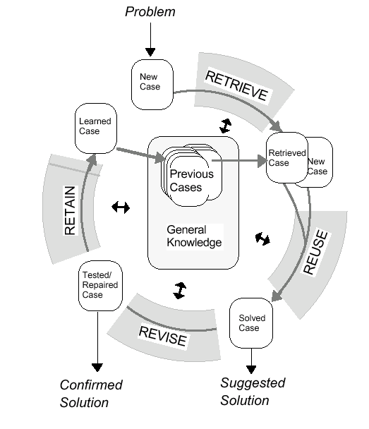

CBR cycle

4. A hierarchy of CBR tasks:
- For describing the detailed mechanisms of the CBR reasoner.
- A CBR system can be described from three perspectives:
- Tasks.
- Methods.
- Domain knowledge.

- All tasks partitions are complete, i.e. the set of subtasks of a task is sufficient to accomplish that task.
- The method set is incomplete, i.e. one of the methods indicated might be sufficient to solve that task or several methods may be combined or there may be other methods that can do the job.

5. CBR Problem Areas:
- Knowledge representation.
- Retrieval methods.
- Reuse methods.
- Revise methods.
- Retain methods.

Representation of Cases:

- A case-based reasoner is heavily dependent on the structure and content of its collection of cases (case memory).
- Case search and matching processes need to be both effective and reasonably time efficient.
- Integration of a new case into the case memory needs to be efficient.
- What to store in a case and how to store.
- How to organize and index the case memory for effective retrieval and reuse.
- How to integrate the case memory into the general domain knowledge model.
- Two influential case memory models:
- The Dynamic Memory Model.
- The Category and Exemplar Model.

1. The Dynamic Memory Model:
- Hierarchy structure of “episodic memory organization packets,” Generalized Episodes, GE
- Three different types of objects in a GE:
- Norms.
- Cases.
- Indices.

2. The Category and Exemplar Model:
- Cases are referred to as exemplars, because cases are defined extensionally.
- Different features are assigned different importance in describing a case’s membership to a category.
- The case memory is embedded in a network structure of categories, semantic relations, cases and index pointers.
- Indices are of three kinds:
- Feature links.
- Case links.
- Difference links.

- A feature is described by a name and a value.
- A category’s cases are sorted according to their degree of prototypically in the category.
- The categories are inter-linked within a semantic network.

Case Retrieval:

- Starts with a (partial) problem description and ends when a best matching previous case has been found.
- 3 subtasks:
- Identify features.
- Initial Match.
- Search and Select.

- Cases are retrieved based on:
- Syntactical similarities
- Semantical similarities.
Subtask1: Identify features
- Simply notice the input descriptors or ‘Understand the problem’.
- Unknown descriptors may be disregarded or requested to be explained.
- Filter noisy problem descriptors.
- Infer other relevant problem features.
- Check if the feature values make sense within the context or not.
- To generate expectations of other features.

Subtask 2: Initial Match
- Retrieve a set of similar cases.
- Three ways of retrieving:
- Follow direct index pointers.
- Searching an index structure.
- Searching in the general domain knowledge.

- Cases can be retrieved solely from input features or from the inferred features.
- Match all features or match according to some degree of similarity.
- To calculate the degree of similarity either deeply understand the problem or give weighs to the problem descriptors.

Subtask 3: Search and Select
- The cases are ranked according to some metric or ranking criteria.

Case Reuse:
- Focuses on two aspects:
- The differences between the past and the current case.
- What part of retrieved case can be transferred to the new case.
- Two subtasks of Reuse:
- Copy.
- Adapt.

1. Copy:
- Don’t care about differences.
- Solution of new case is solution of retrieved case.

2. Adapt:
- Two main ways to adapt retrieved solutions:
- Transformational reuse.
- Derivational reuse.
Case Revision:
- Consists of two tasks:
- Evaluate the solution.
- Repair the fault.

Evaluate the solution:
- Verification / Evaluation by computer simulation or in the real world.
- Real world evaluation may take some time.
- Criteria for revision:
- Correctness of the solution.
- Quality of the solution.
- Other, e.g., user preferences.

Repair the fault:
- Detect the errors of the solution.
- Store the failure in a failure memory (learning).
- Modify the solution using the failure explanations.
Case Retainment – Learning:
- To learn from the success or failure of the solution.
- Three subtasks:
- Extract.
- Index.
- Integrate.
1. Extract:
- A new case may be built or the old case may be generalized to subsume the present case.
- What to retain?
- Relevant problem descriptors.
- Problem solutions.
- Explanation as to why the solution is a solution to the problem.
- Problem solving method.
- Failures.

2. Index:
- The ‘indexing problem’ is a central and much focused problem in CBR.
- What type of indexes to use for future retrieval?
- How to structure the search space of indexes?

3. Integrate:
- Aim is to make the retrieval of cases in the future more efficient.
- Need to modify the indexing of existing cases.
- Integration in which part of the case memory depends on the features that have been judged relevant for retrieving a successful case.
Integrated Approaches:
- CBR is the core part of a target system’s reasoning method.
- A CBR system initially will not have much of case memory.
- There will be times when the case-based method will fail to provide a correct solution.
- Hence we need other methods in addition to the case-based reasoning.
Applications:
1. CBR system at Lockheed, Palo Alto.
- Optimization of autoclave loading for heat treatment of composite materials (resource allocation problem).
- Few experienced people, no theory, few generally applicable schemes.
- CBR can be used to build up experience.
- Enable other people other than experts to do the job.
- Training of new personnel.

2. CBR system at General Dynamics, Electric Boat
Division:
- Selection of most appropriate mechanical equipment and to fit it to its use (resource allocation problem).
- No regular procedures.
- Rule-based system was found to be ineffective.

3. Help desk systems:
- In these systems case-based indexing and retrieval methods are used to retrieve cases, which is the information needed by the user. They are not used as sources of knowledge for reasoning.
TOOLS:
Several commercial companies offer shells for building CBR systems. For example:
- ReMind
- CBR Express / ART-IM
- Esteem
- Induce-it
- KATE-CBR
- ReCall
- S3-Case

Conclusions and Future Trends:
- CBR emphasizes problem solving and learning as two sides of the same coin.
- The development trends of CBR methods can be grouped around 4 main topics:
- Integration with other learning methods.
- Integration with other reasoning components.
- Incorporation into massive parallel processing.
- Method advances by focusing on new cognitive aspects.

